Sustainable procurement tools: Register and login
Contents
1. To register 2
2. To login 3
3. Forgotten Login 4

To register
https://sustainableprocurementtools.scot/

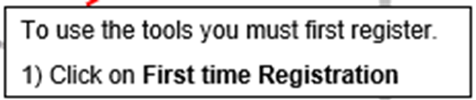
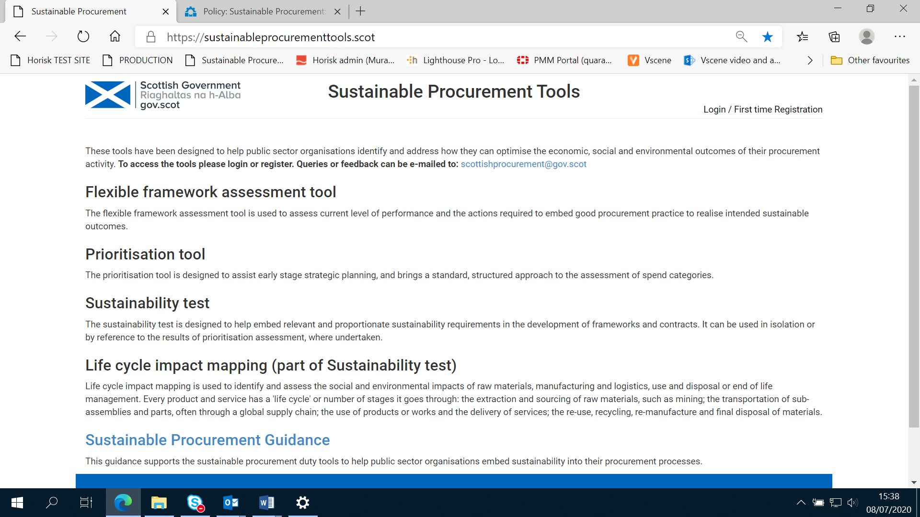

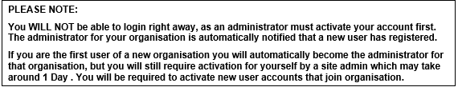
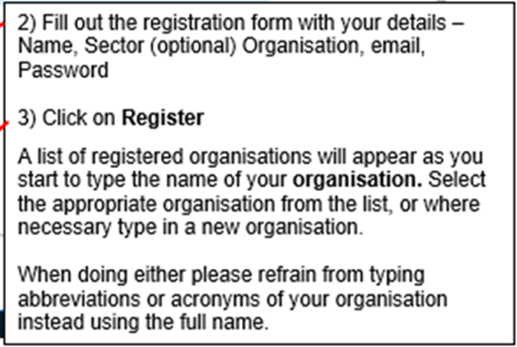
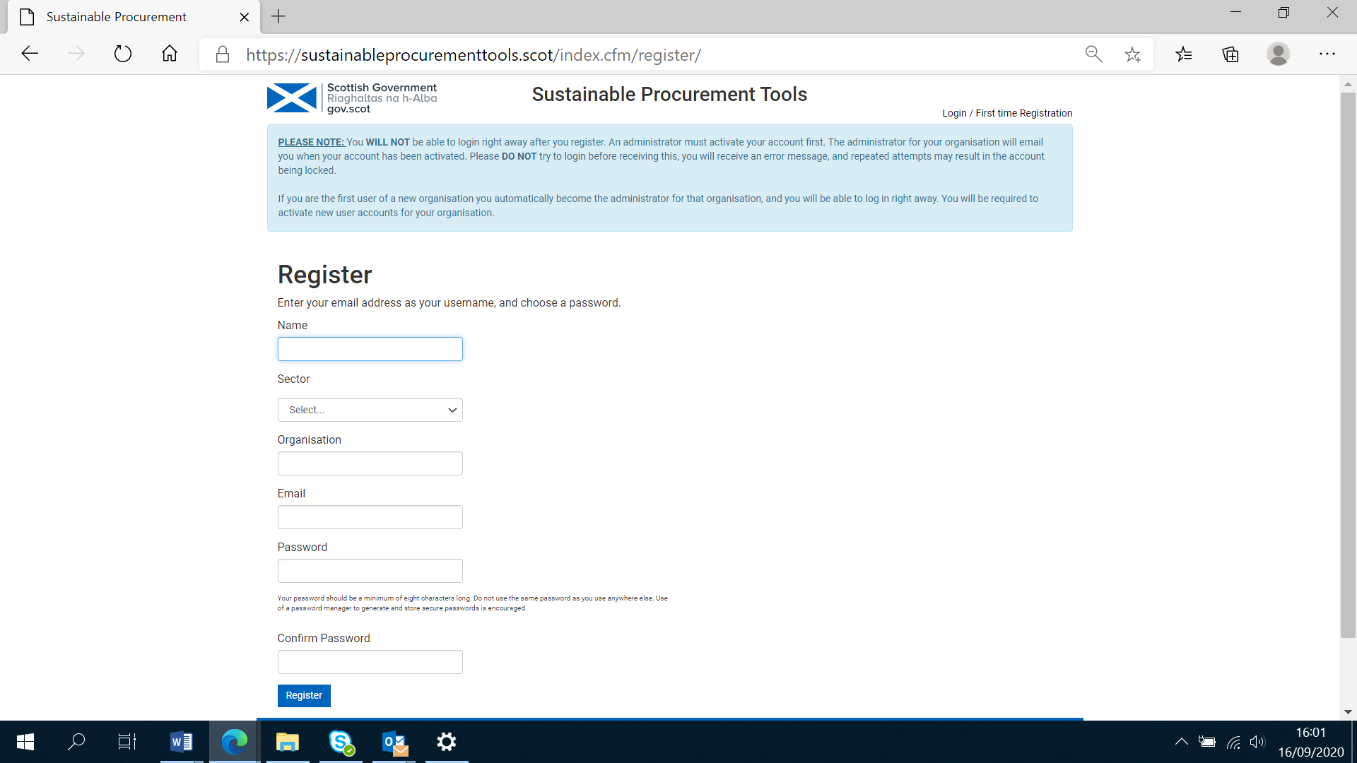

Return to Contents
PLEASE NOTE:

You WILL NOT be able to login right away, as an administrator must activate your account first. The administrator for your organisation is automatically notified that a new user has registered.

If you are the first user of an organisation you will automatically become the administrator for that organisation, and you will be able to log in right away. You will be required to activate new user accounts for your organisation.

To login

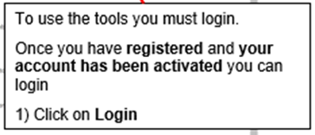

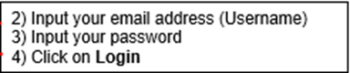
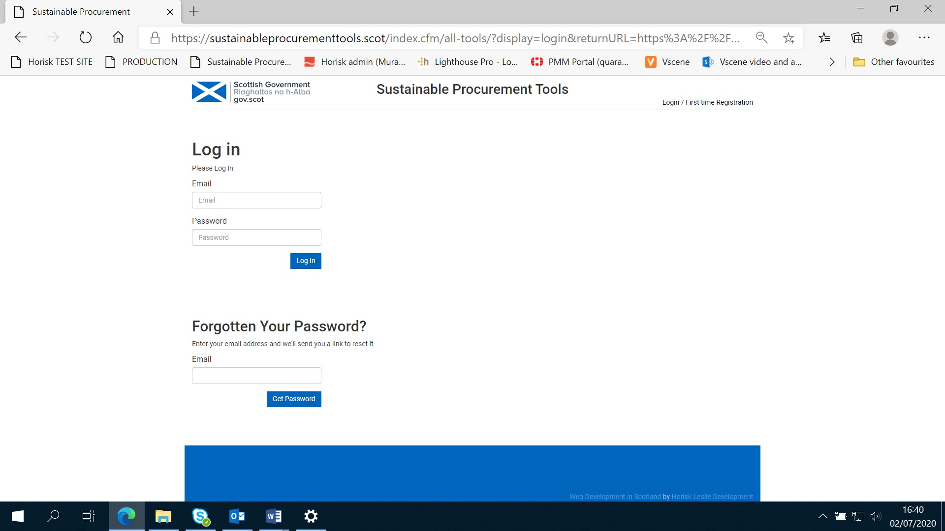

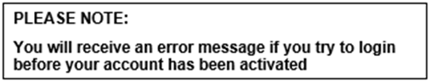

Any feedback can be sent to scottishprocurement@gov.scot

Return to Contents

Forgotten Login

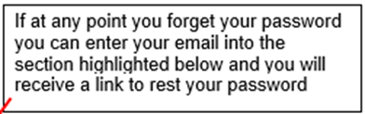
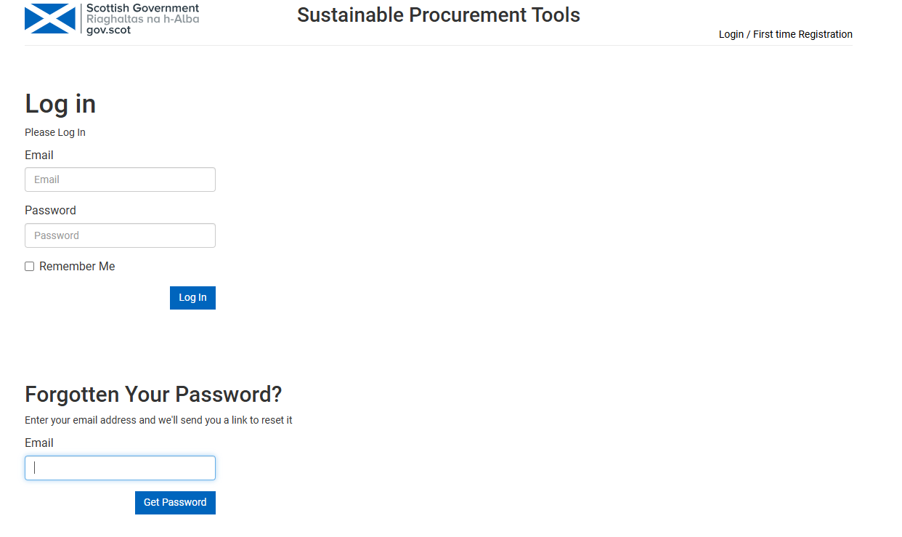

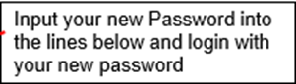
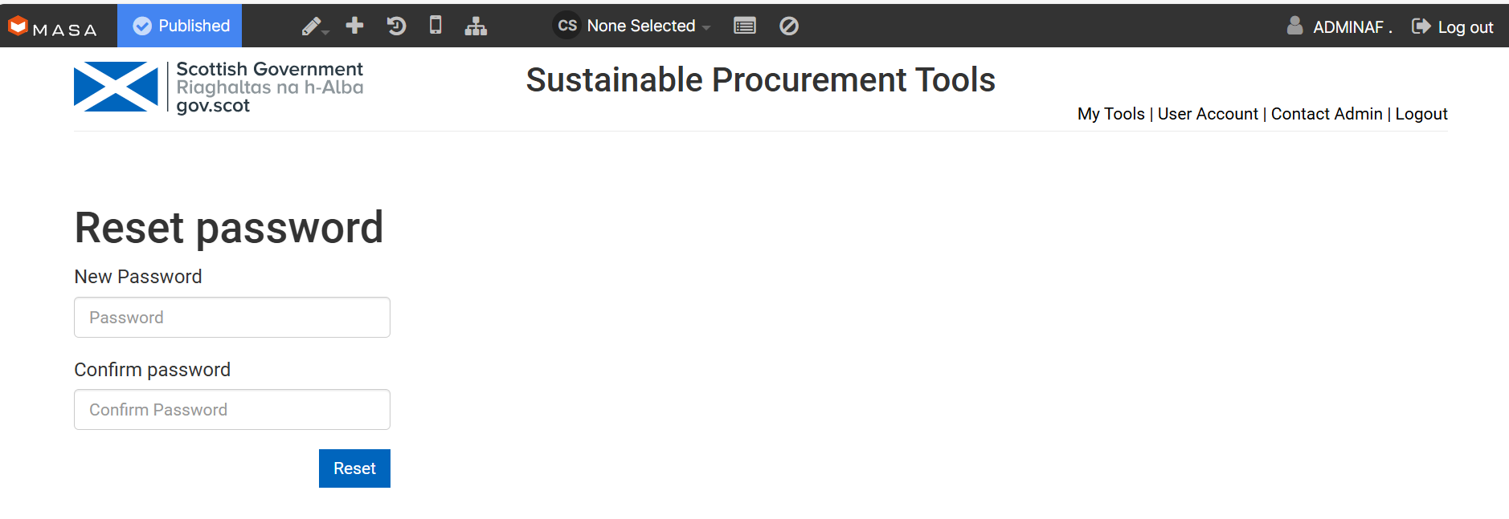

If you experience any issues or queries about registration or logging in contact scottishprocurement@gov.scot

Return to Contents

