Local Administrator user guide

Contents
1. Introduction 2
2. Help and support 2
3. Managing user accounts 3
4. Activate a new user 4
5. Grant or revoke user access to the tools 6
6. Set default organisation access permissions to the tools 7
7. Make a user an administrator 9
8. Change a user's password 10

Introduction
When a user registers on the sustainable procurement tools website with an organisation name that hasn’t been used before, a new organisation is created. As the first and only user of this organisation, they automatically become the local administrator for that organisation.

As the local administrator they will be required to activate new user accounts for their organisation. This enables an organisation to self-manage their own instance and users.

Local administrator accounts must be activated by a site administrator before they can login for the first time. Site administrators receive system generated notification of registrations and when new organisations are created. Please note that there may be a slight delay between registration and account activation, to allow a site administrator to validate accounts. New local administrators will receive an email from a site administrator when their account has been activated, and only then can they login.

Users are required to register with their organisation so they can be associated with their colleagues allowing collaboration, this also enables local administrators to manage their own organisation and users. New user accounts that create a duplicate organisation when they register will be moved into the existing organisation by site administrators.

Help and support
There are a number of user guides and short videos available on using the tools, these are available from the User Guides, Videos and other resources page.

Any enquiries regarding the website including registration and account activation queries should be directed to the site administrators at: scottishprocurement@gov.scot'

Managing user accounts
Once you have logged in with the credentials you registered with you can manage your organisations user accounts. For help to register and login, please see the Register and login user guide or video.

From the landing page click on the User List link at the top right of the screen:
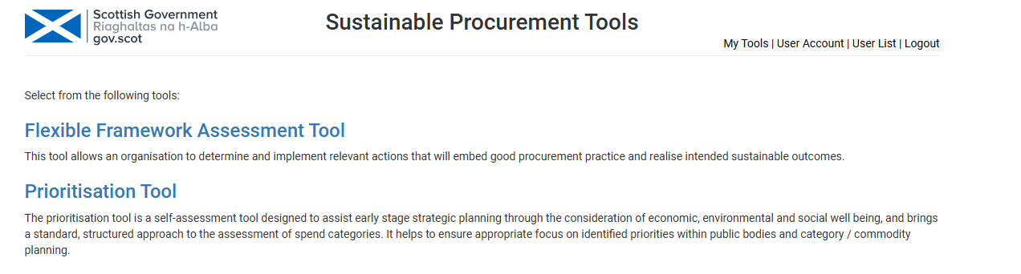
Clicking on the User List shows the users in your organisation:

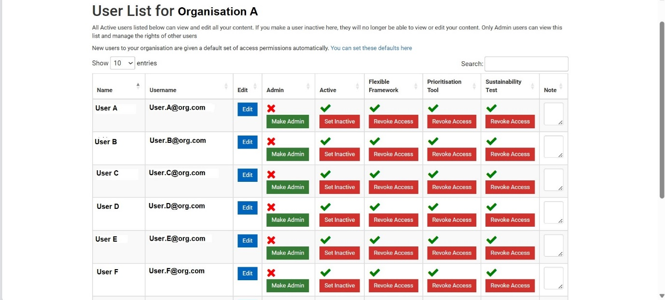

If you can access the above page, you are a local administrator for your organisation. The user list is only available to administrators. From here you can:
- search for users using the search box
- sort by each field for example by Name or Username so users appear in ascending (A to Z) or descending (Z to A) alphabetical order
- change a user’s password
- add a note to a user’s account.

Activate a new user
You should have received a system generated e-mail notifying you of a new registration and to activate their account. Please see the following example:

These e-mails may get caught in the spam folder in your mailbox, please check it regularly.

When a new user registers, they will receive a system generated message

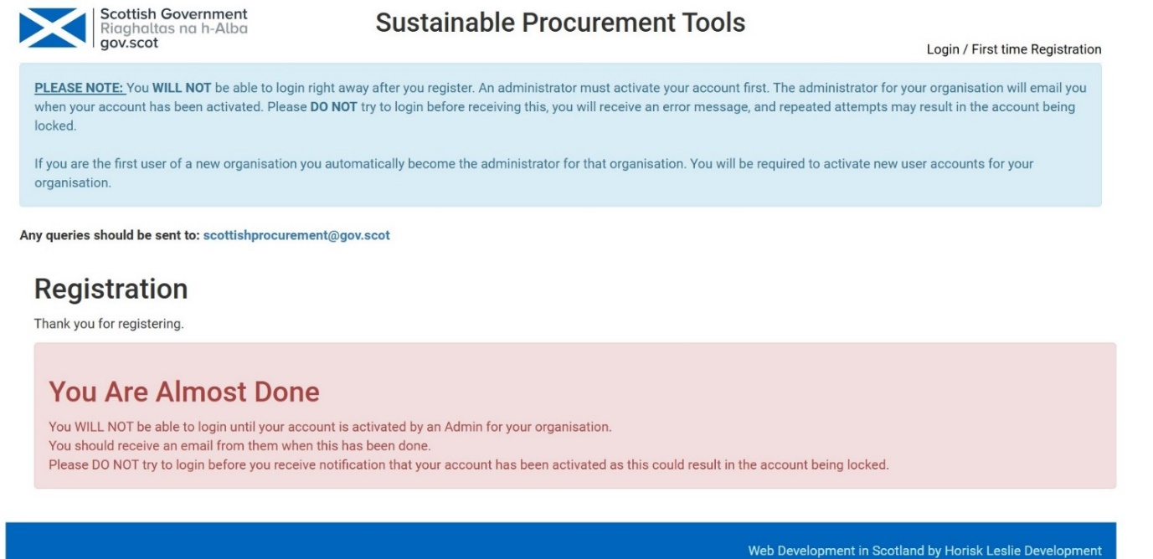
The new user account will appear in your User List. Look for the user you wish to activate and click on the green Set Active button:

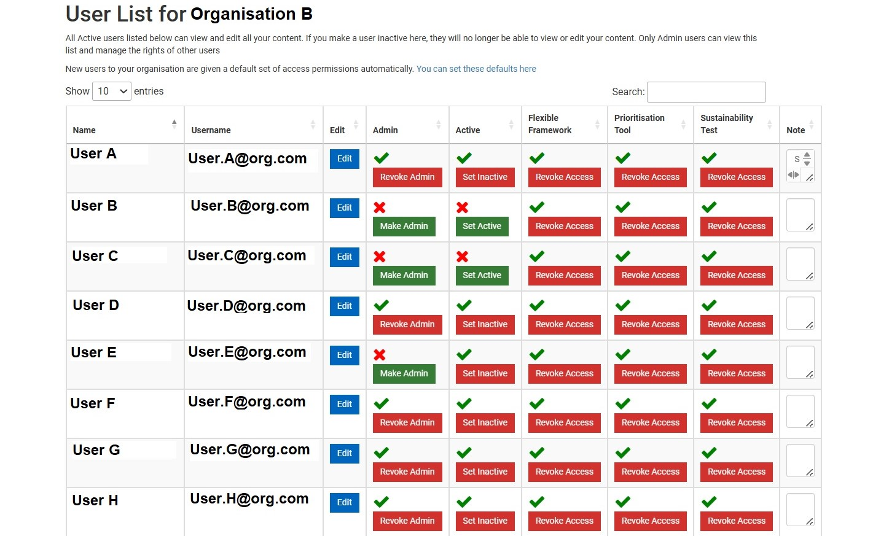

The status of the user will change to Set Inactive:

To make a user account inactive click on the red Set Inactive button

Grant or revoke user access to the tools
A local administrator can grant or revoke access to each tool (Flexible Framework, Prioritisation Tool and Sustainability Test) for individual users.

From the User List page look for the relevant user. Click on the red Revoke Access button to restrict access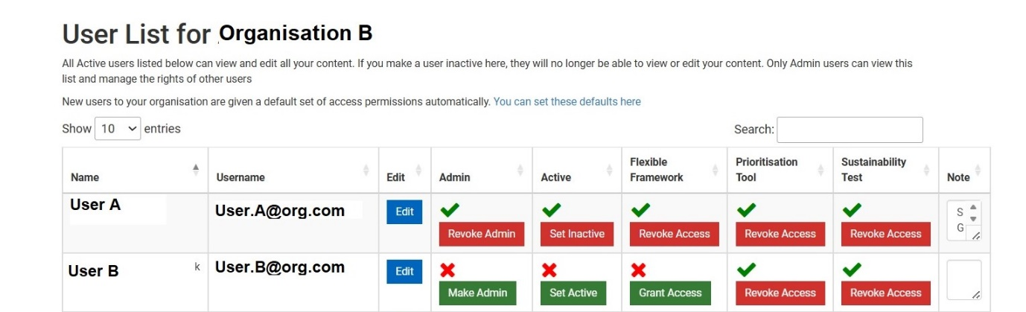

To give a user access to one of the tools click on the green Grant Access button.

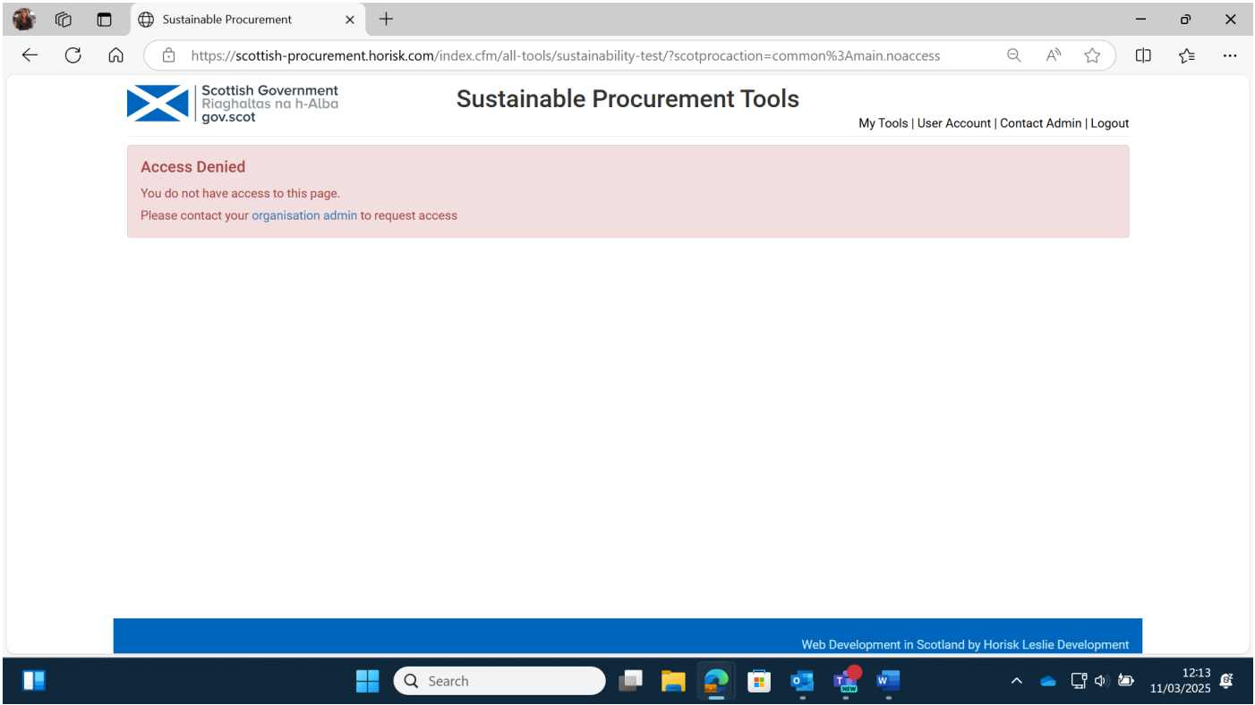
Users who do not have access to a tool will receive an Access Denied message with a link to the Contact Admin page so they can e-mail their local administrator to request access:
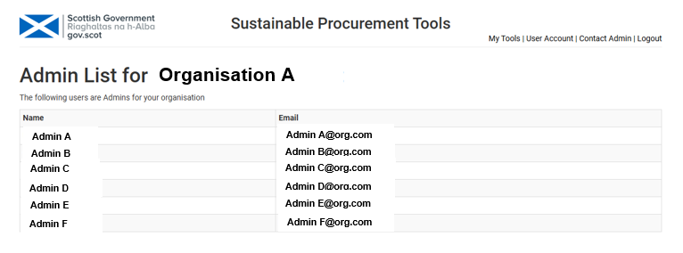
Clicking on the organisation admin link above takes the user to their list of administrators:

Set default organisation access permissions to the tools
Local Administrators can set default access for new user accounts. This sets permissions automatically to block or allow access to each tool (Flexible Framework, Prioritisation Tool and Sustainability Test).
From the User List page click on the defaults link located above the list of users:

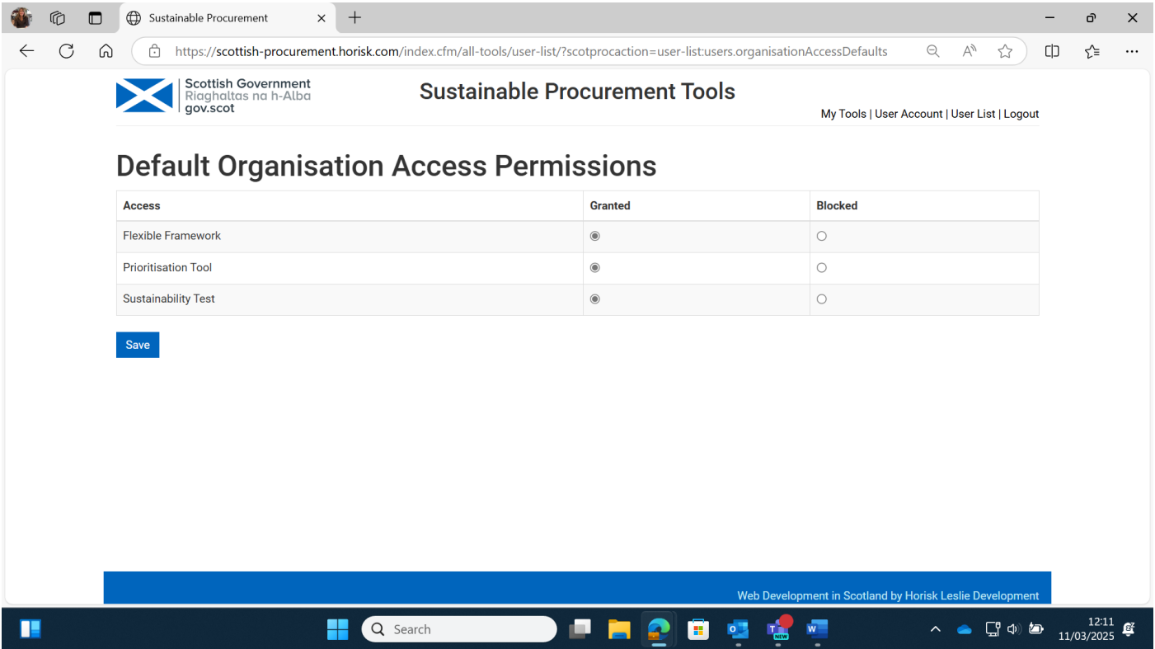
This takes you to the Default Organisation Access Permissions page. You can set the default access you wish to apply to your organisation by clicking on Granted or Blocked, and then Save:

Make a user an administrator
Administrator rights can be given to additional users or be transferred to another user. There should always be at least one administrator in your organisation, and it is good practice to have more than one administrator, where this is possible.
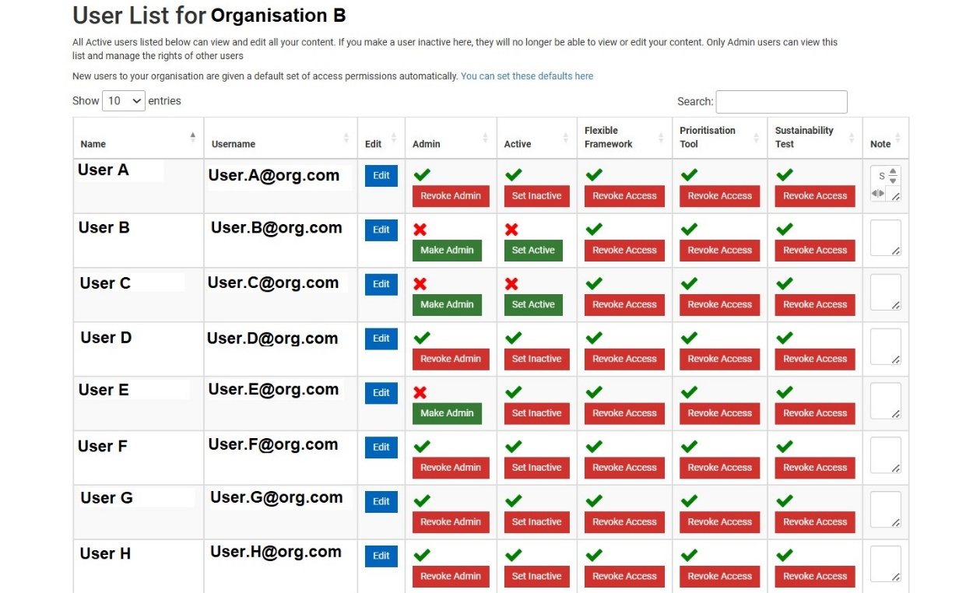

Click on the green Make Admin button. The user’s status will change to Revoke Admin.
To revoke a user’s administrator rights, click on the red Revoke Admin button.

Change a user's password
A user can reset their own password by using the Forgotten Your Password function from the login screen.

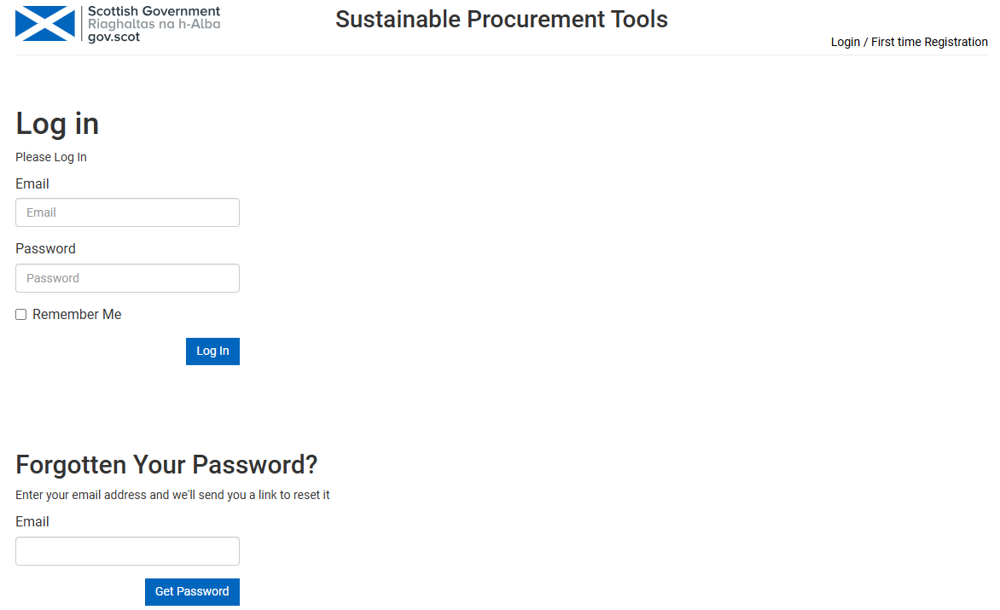
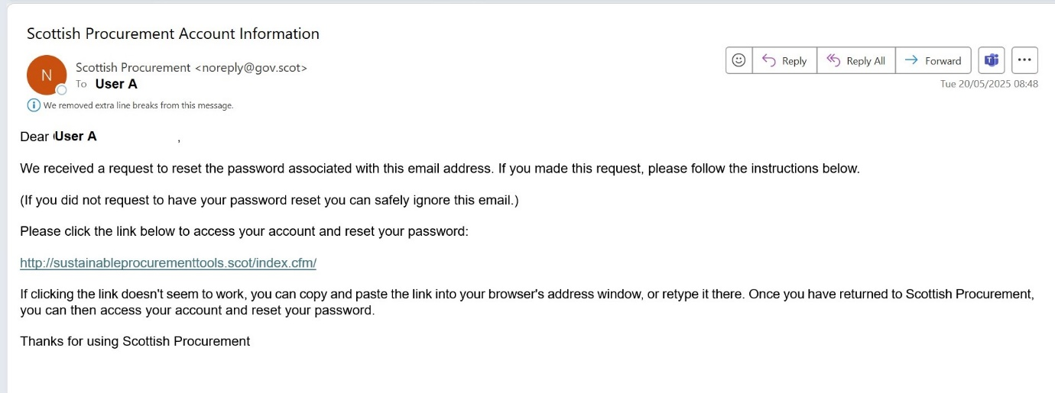

Once the user has input their email address and clicked on the Get Password box they will receive an email with a link to reset their password.

The user clicks on the link within the email and inputs a new password.

The local administrator can also change a user’s password from the User List page.

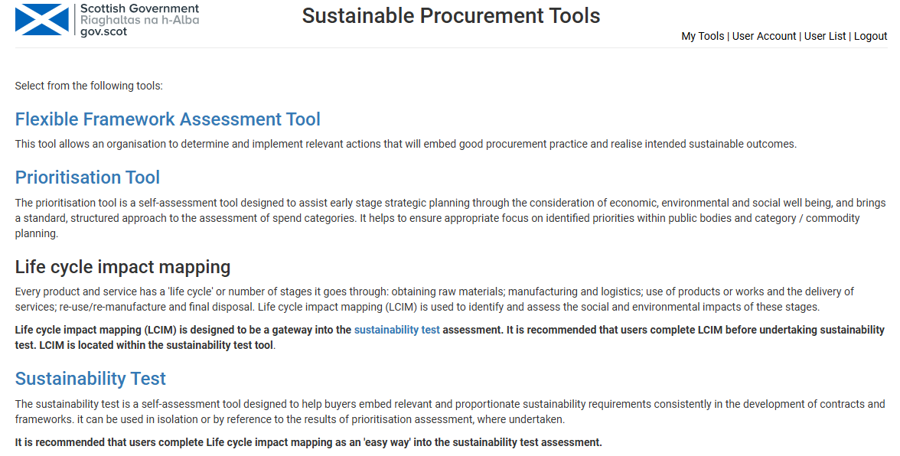

From the User List page click on the blue Edit button next to the relevant user

This will take you to the Edit User page. Input a new password, duplicate the new password in the Confirm Password field and then click on the blue Save button.

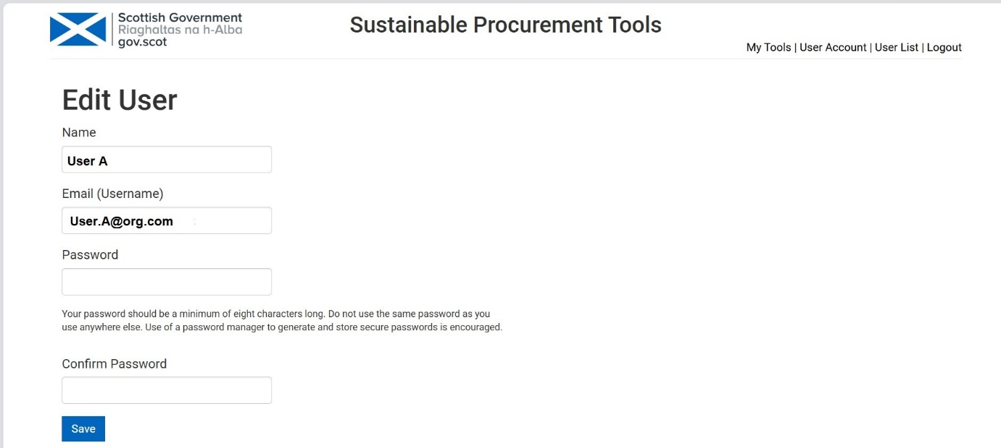

Any feedback can be sent to scottishprocurement@gov.scot

