Sustainability Test User Guide

Contents
1. Introduction 2
2. Relation to Prioritisation Tool 2
3. Who is the tool designed for? 3
4. Who needs to be involved in completing this tool? 3
5. What is this tool designed for? 3
6. Using the tool 3
7. Scotland’s National Performance Framework (NPF) 4
8. National Outcomes 4
9. Register 5
10. Login 7
11. Create a Sustainability Test 9
12. Complete a Sustainability Test assessment 11
12.1 Life cycle impacts 11
12.2 Assess the headline risks 12
13. Summary 17
14. Download Summary 19

Introduction
Note: This guidance complements short videos on the Sustainability Test:
- Introduction to the Sustainability Test.
- Using the Sustainability Test.
These videos use an example of a Cleaning Service contract.

The Sustainability Test is designed to help you embed relevant and proportionate sustainability requirements in the development of contracts and frameworks.
Users of the test are asked to determine whether environmental and socio-economic risks and opportunities are relevant to the subject matter of the contract, to help inform contract requirements.
The Test should therefore be completed when developing a procurement strategy for a contract or framework and/ or when developing tender requirements for the contract or framework. The Life Cycle Impact Mapping tool, as we consider in the separate guidance and videos for this tool, may be used as a gateway to the Test.
Return to Contents

Relation to Prioritisation Tool
The Test may be:
- Used in isolation, as a standalone tool to identify relevant environmental and social risks for a planned procurement and set out intended actions in the procurement process/ cycle.
- Alternatively, it may be used by reference to the results of an early-stage strategic prioritisation of categories, commodities, services or planned pipeline procurements within a Forward Plan, which your organisation may have undertaken.
The Prioritisation Methodology has been designed to bring a standard structured approach to the assessment of spend categories. It is a strategic planning tool that helps inform organisational sustainable procurement priorities and/or category, commodity, services, market engagement strategy. It reflects a balance of:
- Spend,
- risk and opportunity,
- scope to do more to mitigate risks/capture opportunities, and
- influence over the market.
While not mandatory, results from prioritisation may be imported into the Sustainability Test. This helps ensure consistency and a complete audit trail.
The Prioritisation Tool and the Sustainability Test may be used to demonstrate consideration of “Improving economic, social, environmental wellbeing and reducing inequality in the area”, “Involving small and medium enterprises and 3rd sector bodies including supported businesses” and “Promoting Innovation”, as required by the Sustainable Procurement Duty within the Procurement Reform (Scotland) Act 2014.
You may wish to view the separate guidance and videos on the Prioritisation Tool.
Return to Contents

Who is the tool designed for?
This tool is available for all parts of the Scottish public sector, although the principles behind it are suitable for any procuring organisation, subject to adjustment as necessary.

Who needs to be involved in completing this tool?
The Test relies on completion by those who have an understanding of:
- The scope of the framework or contract,
- Relevant categories or commodities,
- The market for these,
- Sustainability risks and opportunities, and what is currently being done to mitigate these risks or capture opportunities, and
- Other relevant information.
In order to effectively complete this tool it should be run in collaboration with a group of stakeholders. While the lead buyer may wish to familiarise themselves with the risks and opportunities relating to the procurement by conducting a light touch sustainability test, collaboration with stakeholders is likely to be required to draw out relevant risks and opportunities.
Relevant stakeholders will depend on your organization – they may include: Commissioners, Heads of service (or their representatives), Category managers, Procurement, Regeneration, Economic development, Sustainable development, Estates and facilities management, Equality and diversity; and others.
Return to Contents

What is this tool designed for?
This tool is designed to be a standard structured approach to the assessment of sustainability to inform contract requirements, for use across the whole of the Scottish public sector.
This risk and opportunity based approach enables resources to be focused on areas with the greatest potential to generate benefits such as financial savings, reduced carbon emissions and waste and community benefits whilst driving innovation, and in turn how national and organisational outcomes may be influenced through the procurement process.

Using the tool
In order for the results from this tool to be as robust as possible, it is important that sufficient information is available. It is good practice that when using the tool, if further work will be needed to obtain or clarify information, relevant risks are assumed to be high, until this information is available.
Considering life cycle impacts by using the Life Cycle Impact Mapping (LCIM) element of the tool is recommended as a quick way of clarifying where risks and opportunities lie, and what that means to application within procurement stages. For more information on LCIM including examples see the Life Cycle Impact Mapping User Guide and videos.
Return to Contents

Create a Sustainability Test
Having logged in (if unclear how to Register and login see the ‘Register and Login’ guidance under ‘User Guides and Videos’:

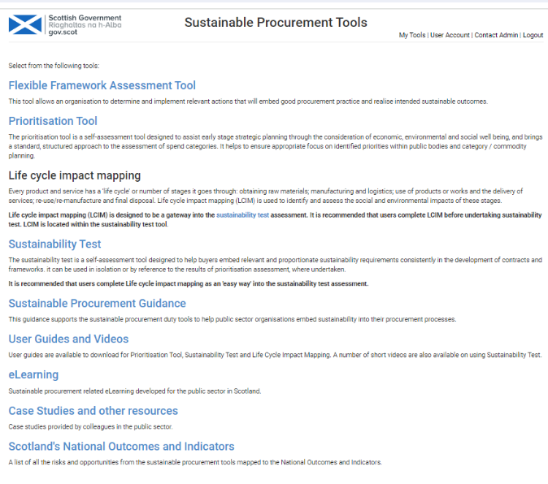
Click on Sustainability Test
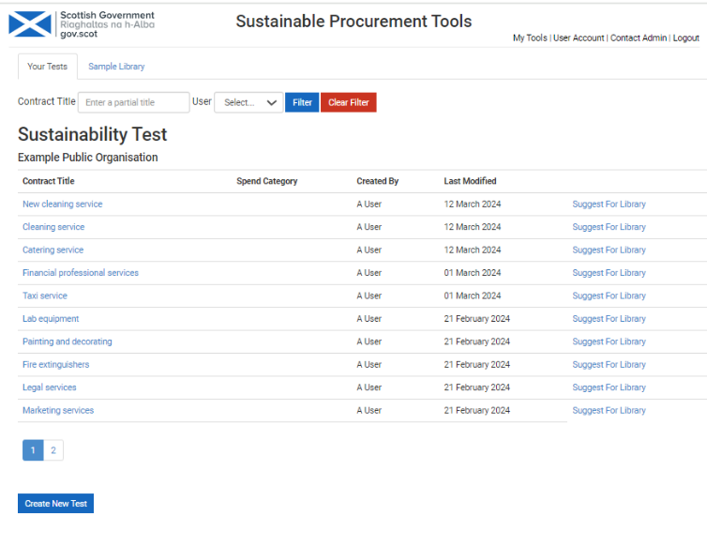
Click on Create New Test.
For information:

All Sustainability Tests created are visible to other users within your organisation.

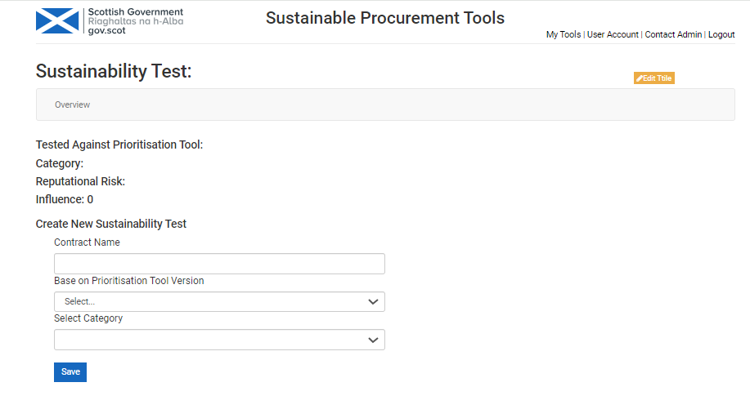
If you are basing this on an earlier prioritisation of categories/ commodities/ services or pipeline projects you can select the relevant prioritisation from the drop down list.
Then select the relevant ‘category’ the contract or framework relates to from ‘Select Category’.
Input the title of the contract or framework being assessed.

PLEASE NOTE:
If you are not basing the Test on an earlier prioritisation assessment leave ‘Base on Prioritisation Tool Version’ and ‘Select Category’ blank.
Then click ‘Save’.

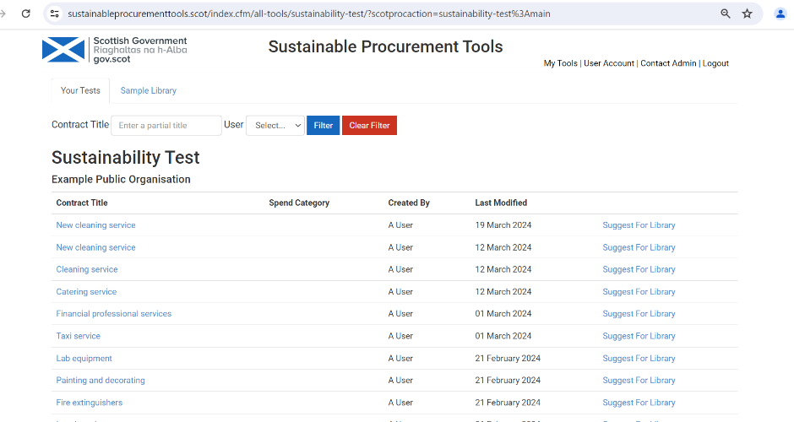
You will be taken to the list of Sustainability Tests you or colleagues in your organisation have completed.
Click on the Test just created.
Return to Contents

Complete a Sustainability Test assessment

Life cycle impacts
Life cycle impact mapping is a quick and simple early assessment of environmental and socio-economic risks and opportunities in the life cycle of the product, service or works being assessed. It can help users understand the extent to which they can address these risks and opportunities, and help determine actions at appropriate stages of the procurement process. It can act as a gateway in to completion of the Sustainability Test. You may have already completed Life Cycle Impact Mapping and are using the results from this to help complete the Test, or you may Identify Life Cycle Impacts when completing the Test.
Note: This guide does not go into detail on Life Cycle Impact Mapping. See the separate Life Cycle Impact Mapping User Guide and videos, including an example.
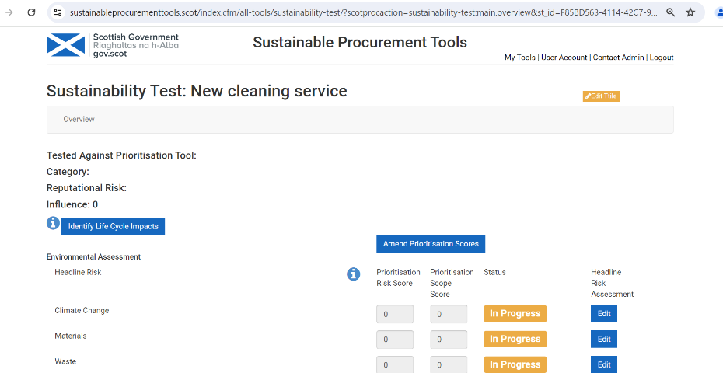
Return to Contents

Assess the headline risks
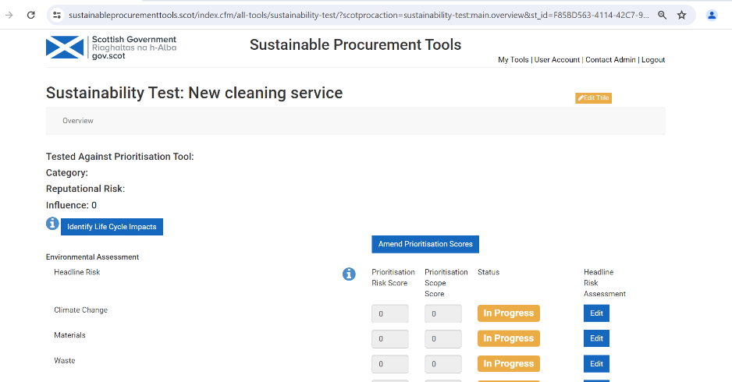

Note: If you are completing the Sustainability Test by reference to results of an earlier assessment of sustainable procurement priorities at category, commodity, service or pipeline project (e.g. within a Forward Plan) (this is not mandatory) scores from the prioritisation will be shown here.
These scores can be amended if required by clicking on ‘Amend Prioritisation Scores’. Once overwritten by the user, the previous scores cannot be retrieved.
Clicking on the ‘i’ icon displays information about the scoring that has been applied during prioritisation assessment.
Click on Edit to assess the headline risks.
This will take you to the detailed assessment page.

Note: The headline risks can be assessed in any order.
The progress of each headline risk assessment is shown in the status field. This will show as ‘In Progress’ until the assessment is complete.

Each headline risk includes a number of elements that are assessed by the Test.

For example, Climate Change is a headline risk and includes 4 elements for detailed assessment:

Carbon – Vehicle Emissions,

Carbon - Energy Consumption,

Carbon – Production,

Climate Change Adaption.

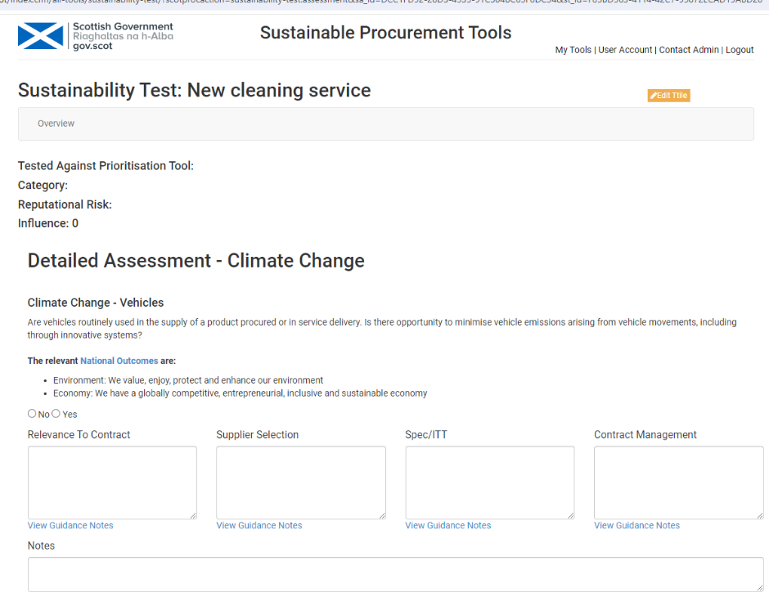
Identify whether the headline risk is relevant to the planned contract or framework (Click Yes or No).
It is good practice to click Yes if you are unclear, so that clarification can then be obtained.
If you have clicked Yes, add notes in ‘Relevance to Contract’ to explain why this is relevant.
If you clicked No, type in ‘n/a’, or similar – otherwise the status in the Overview will be shown as ‘In progress’.
If you click on ‘View Guidance Notes’ this will take you to embedded guidance. This may help you decide what action might be taken at each stage of the procurement process to mitigate risks or capture opportunities:
That underneath ‘Relevance to Contract’ provides guidance through the procurement cycle regarding the specific headline risk (see example below*).
That underneath Supplier Selection, Spec/ITT and Contract Management provides general procurement cycle guidance.

Note: At any time when completing the detailed assessment, the user can click on Overview to return to the overview of their Sustainability Test.
The guidance is also available from the home page of the Tools portal under ‘Sustainable Procurement Guidance’ – you do not need to login to access this.

*Example of available guidance – in this case for ‘Climate Change – Vehicles’ (this would open in a separate window):
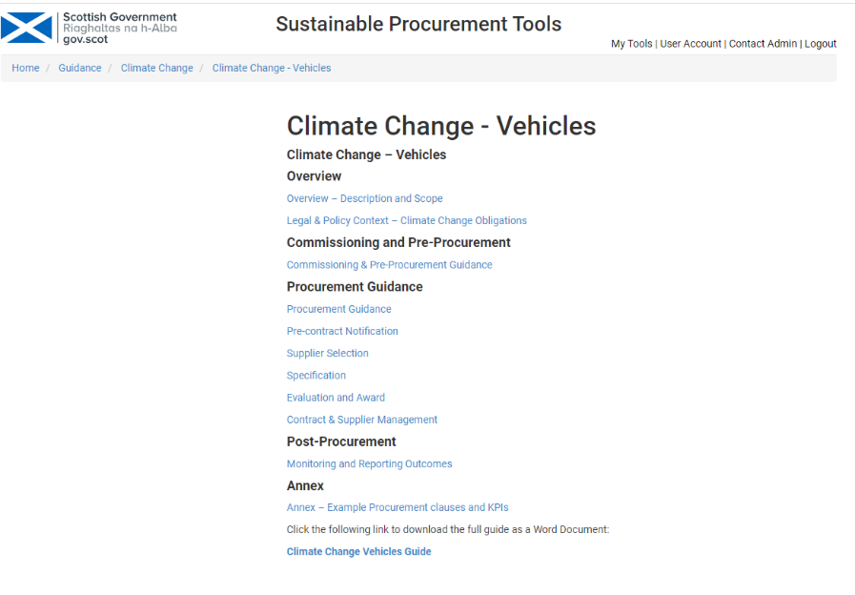

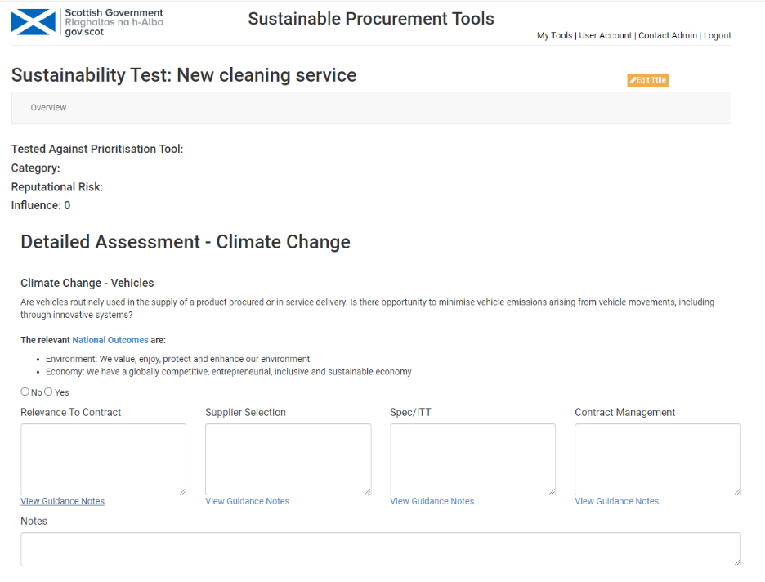
If you assessed the headline risk as being relevant complete these boxes with intended actions at each stage of the procurement process.

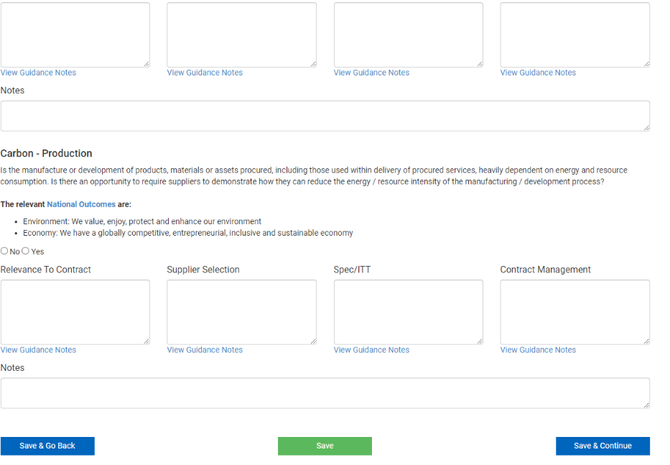

Once all the headline risks have been assessed and relevant information and actions included, Save:
Save and Go Back: saves your detail and takes you to the previous assessment.
Save: saves your detail and keeps you on the current page.
Save and Continue: saves your detail and takes you to the next assessment, or where you have completed al of them, to the Overview.

Return to Contents

Summary
Within the ‘Overview’ you can click on ‘View Summary. This provides an overview of their completed Sustainability Test. The summary can be viewed, downloaded and saved locally, shared with colleagues, or incorporated into the procurement strategy, etc. as required.
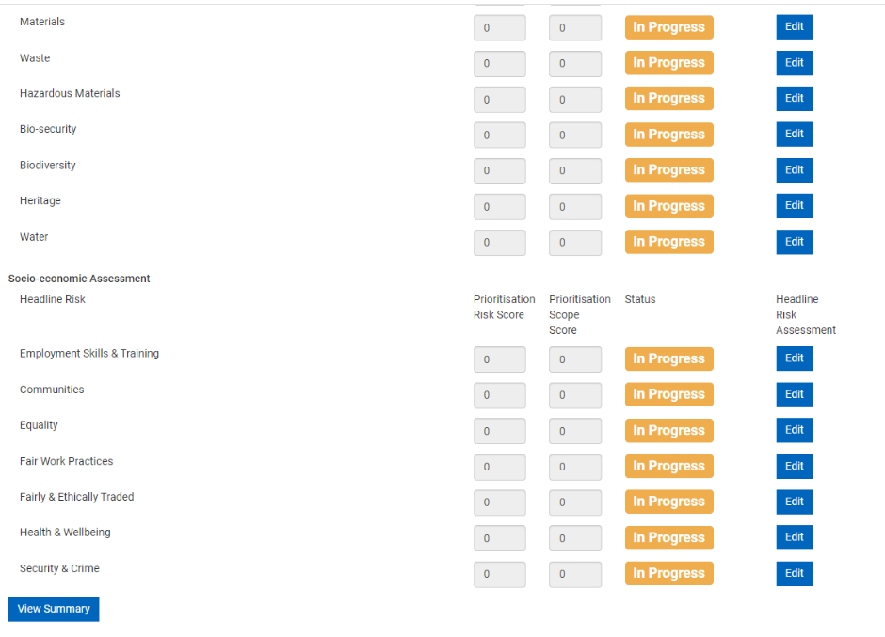
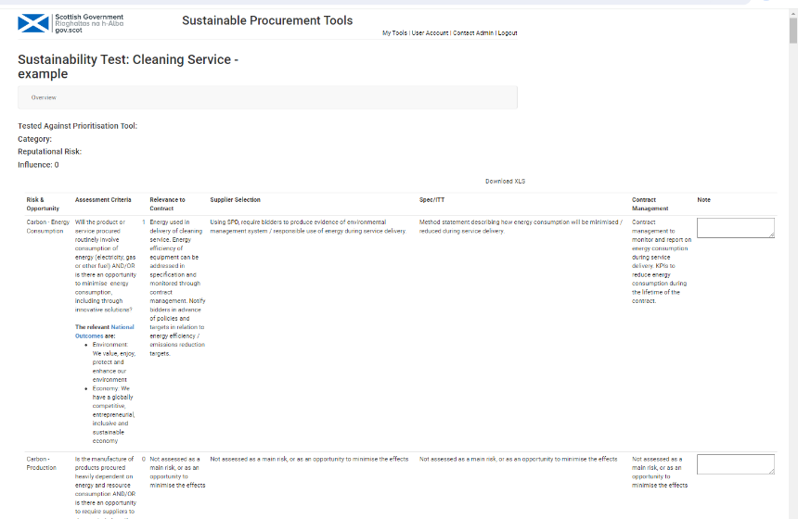
In the Summary the scores of 1 or 0 show whether the headline risk has been assessed as relevant or not.
You can include notes if you wish.

Download Summary
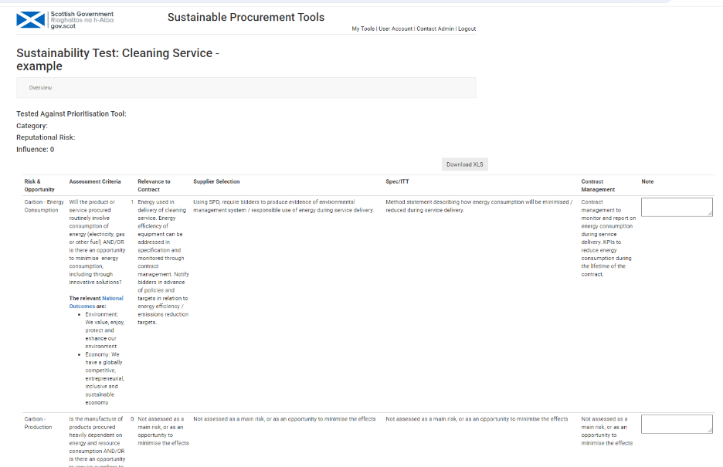
Download the Summary by clicking on ‘Download XLS’. The spreadsheet summary can then be saved locally.

Any feedback or questions regarding the tools can be sent to scottishprocurement@gov.scot

Return to Contents

