Prioritisation Tool User Guide
Contents
1. Introduction 2
2. Who is this tool designed for? 3
3. Who needs to be involved in completing this tool? 3
4. What is this tool designed for? 4
5. What are the key outputs from this tool? 5
6. Scotland’s National Performance Framework (NPF) 6
7. Scotland’s National Outcomes 6
8. Using the tool 8
9. Register and Login 9
10. Create a prioritisation tool 10
11. Complete a prioritisation assessment 12
11.1 Input strategies 12
11.2 Adding issues 15
12. Complete a prioritisation assessment - input ‘categories’ & spend 15
13. Complete a prioritisation assessment - assess risks & opportunities 18
14. Complete a prioritisation assessment - assess influence 20
14.1 Assessment of market influence 20
14.2 Influence assessment considerations 21
15. Overview - results of prioritisation assessment 24
15.1 Status of assessment 24
15.2 Risk vs Spend 24
15.3 Scope vs Risk matrix 27
15.4 Scope v’s Influence matrix 27
15.5 Overall graph 28
16. Results of prioritisation assessment – summary 30
17. Prioritisation assessments – duplicating 31

Introduction
Note: This guidance complements short videos:
- Introduction to the Prioritisation Tool.
- Using the Prioritisation Tool.
This tool is designed to assist early-stage strategic planning through the consideration of economic, environmental and social wellbeing as required by the Procurement Reform (Scotland) Act 2014 and ensures appropriate focus on identified priorities within category, commodity, services or pipeline projects planning.
Prioritisation will help inform relevant strategies (or equivalent) as well as pre-procurement market engagement – reinforcing the importance of embedding sustainability early in pre-procurement processes and the procurement cycle.
Such high-level prioritisation would normally be undertaken annually and may be helpful in informing organisational procurement strategies and / or as a way of prioritising projects within Forward Plans, or the focus on single issues.
Considering sustainability early in pre-procurement and the procurement process is recommended to:
- achieve identification of risks and opportunities prior to commissioning suppliers.
- understand the scope for sustainability outcomes and ensure that ability to influence sustainable outcomes is optimised.
- determine all relevant life cycle cost considerations.

Return to Contents

Who is this tool designed for?
This tool is available for all parts of the Scottish Public Sector, although the principles behind it are suitable for any procuring organisation, subject to adjustment as necessary.

Who needs to be involved in completing this tool?
As a strategic planning tool, it relies on completion by those who have an understanding of the assessed categories, commodities, services or pipeline projects, spend on them, the market for these, sustainability risks and opportunities, what is currently being done to mitigate risks or capture opportunities and other relevant information.
In order to effectively complete (or update) the Prioritisation this should be run in collaboration with a group of stakeholders – it is not designed to be carried out by an individual alone (subject to the nature of the organisation). You need those involved who understand organisational objectives, sustainability, categories and markets. Stakeholders could include:
- commissioners
- heads of service (or their representatives)
- category managers
- procurement
- regeneration
- economic development
- sustainable development
- environmental management
- estates and facilities management
- equality and diversity; and
- any relevant others

What is this tool designed for?
This tool is designed to be a standard structured approach to the assessment of spend ‘categories’, for use across the whole of the Scottish public sector. This risk and opportunity-based approach enables resources to be focused on areas with the greatest potential to generate benefits such as financial savings, reduced carbon emissions and waste and community benefits whilst driving innovation, and in turn how national and organisational outcomes may be influenced through the procurement process. This tool is therefore designed to:
- help procuring organisations prioritise categories, sub-categories, existing contracts or pipeline projects, according to sustainability risks and opportunities, and highlight subsequent actions.
- inform organisational procurement strategies.
- highlight those categories, commodities, services, existing contracts or pipeline projects where particular risks and opportunities are relevant.
- highlight how category and procurement strategies may seek to mitigate relevant risks or capture opportunities.
- highlight a relevant focus on market engagement.
- act as a reference for the subsequent development of contracts and frameworks, through the Sustainability Test.
- provide an evidence base for category and procurement strategies and eventual contract requirements.
- assess relevant options - for example when considering varying options for future procurements.
- highlight single issue priorities - i.e. identifying within which particular categories, commodities, services, contracts or pipeline projects specific environmental and socio-economic risks and opportunities are relevant, so that market engagement and procurement strategies may be focused (e.g. labour standards within the supply chain).
Return to Contents

What are the key outputs from this tool?
The outputs are:
- a matrix comparing ‘Spend’ v ‘Risks and Opportunities’ highlighting which categories or others are priorities;
- a matrix comparing ‘Risks and Opportunities’ v ‘Scope’ to do more to mitigate the identified risks or capture the opportunities, highlighting which are the key categories or others where buyers can address these;
- a matrix comparing ‘Scope’ v ‘Influence’ of the organisation over the market, highlighting the key categories or others where the organisation can achieve improved sustainable outcomes through effective market engagement.
- an overall summary graph, combining ‘Risks and Opportunities’, ‘Scope’ and ‘Influence’.
- an overall summary of scores and comments, which can be exported to help inform the relevant strategy.

Re-visit results:
You can and should be prepared to re-visit the results of the tool, to inform category and market engagement strategies. The tool can be used more than once – for example, while initial prioritisation may be undertaken at category level, it is useful to then analyse sub-categories. By revisiting the tool, you can track progress in embedding sustainable outcomes and secure wider buy-in. It is recommended that you undertake or update the results of the tool on a regular basis (perhaps annually) to ensure that it reflects current planned expenditure and organisational priorities.
Refer to results when developing contracts:
The results of the tool can also be a useful reference when you are developing frameworks and contracts.
While prioritisation may have been undertaken at category level, it can provide a useful reference to ensure contract requirements are aligned with earlier high level assessment.
The results of the tool may therefore be exported to the Sustainability Test, to act as a reference when assessing risks and opportunities in the development of frameworks or contracts. See the Sustainability Test guidance for more information.
Return to Contents

Scotland’s National Performance Framework (NPF)
The NPF is for all of Scotland, to which all public services in Scotland are aligned, encouraging more effective partnership working. Our purpose is to focus on creating a more successful country with opportunities for all of Scotland to flourish through increased wellbeing, and sustainable and inclusive economic growth. The NPF is available here.

Scotland’s National Outcomes
Scotland’s National Outcomes describe what Scotland wants to achieve and the kind of Scotland we want to see. The link from Scotland's National Outcomes to relevant clearly articulated organisational objectives and outcomes will in turn require an understanding of which objectives have high priorities for the organisation and also category of procurement / commodity / contract.

- chief Executives, CFOs, Ministers, Members and others, need to understand what their organisation should be seeking and set in motion processes to enable this to be applied throughout the organisation, including how this links to the procurement of goods and services
- the above process ensures that a clearly defined, relevant and future proofed set of risks and opportunities has been identified against which to assess categories / commodities / contracts
- there is a need for consistency in adopting key principles across the Scottish public sector and in setting and prioritising policy objectives, subject to sector specific issues
- all parts of the public sector will relate to environmental and socio-economic risks and opportunities but may need to adjust and weight these to suit their particular focus
Return to Contents

Using the tool
For the results from this tool to be as robust as possible, it is important that sufficient information is available.
It is possible that further work will be needed to obtain or clarify information. If this is the case, it is recommended that when using the tool relevant risks are assumed to be high, until information is available to clarify this.
In order to undertake Prioritisation there are a number of key requirements:
- spend data for categories, commodities, services – ideally this should be planned expenditure for a 12-month period. If prioritising contract register or pipeline projects estimated or actual expenditure is required
- an understanding of organisational procurement policy objectives
- an understanding of categories being assessed – their scope, the market, risks and opportunities
Navigate through the tool by completing the details of any relevant organisational strategies, creating your categories and adding their spend. Then you can work your way through the assessment of each category.
Return to Contents

Register and Login

Please see attached below a link to the relevant register and login guidance that covers how to set up and access your own account.
Sustainable Procurement

Return to Contents

Create a prioritisation tool
Having logged in (if unclear how to Register and login see the ‘Register and Login’ guidance above under ‘User Guides and Videos’:

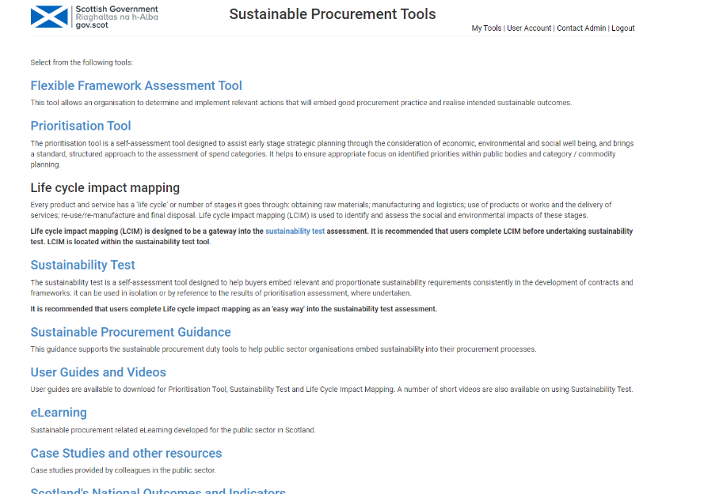
- Click on ‘Prioritisation Tool’

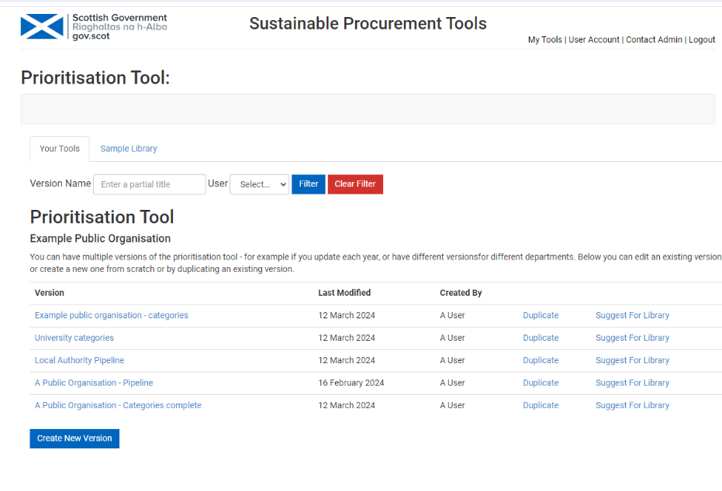
2. Click on ‘Create New Version’
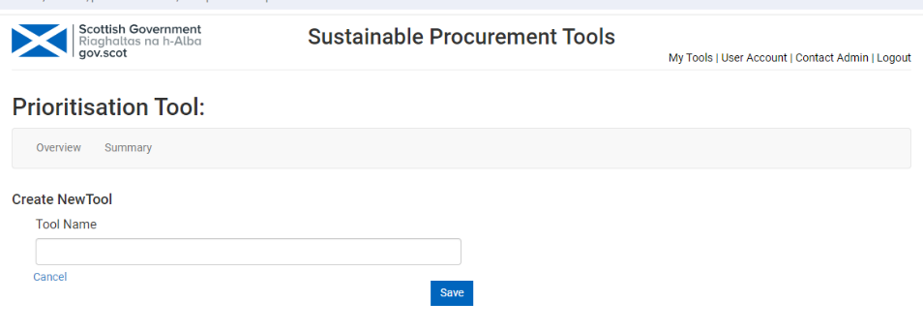
3. Type in the title name of the prioritisation.
Then click Save.

Complete a prioritisation assessment

Input strategies
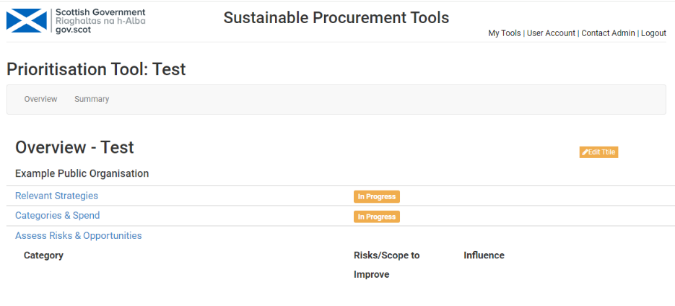
4. Click on ‘Relevant Strategies’.

Note: You can go to an Overview of the assessment by clicking on ‘Overview’.
Return to Contents

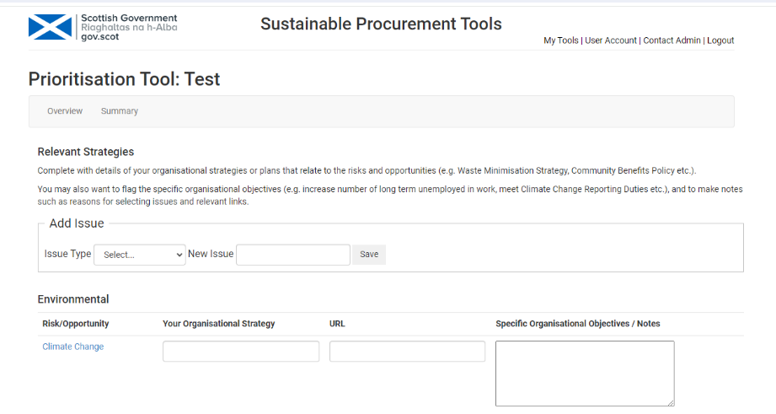
This is where you can input details of your organisational strategies, plans or specific objectives that relate to the risks and opportunities (e.g. Carbon Reduction Plan, Waste Minimisation Strategy, Community Benefits Policy etc.) and relevant URLs.
It is helpful to input relevant strategies as this can help to demonstrate alignment with these, particularly those that require reporting of outcomes.
You may also want to flag specific organisational objectives (e.g. increase number of long term unemployed in work, meet Climate Change Reporting Duties etc.), and note reasons for selecting issues and relevant links.
Clicking on each of the headline risks takes you to embedded procurement guidance relating to that risk. See example below*.
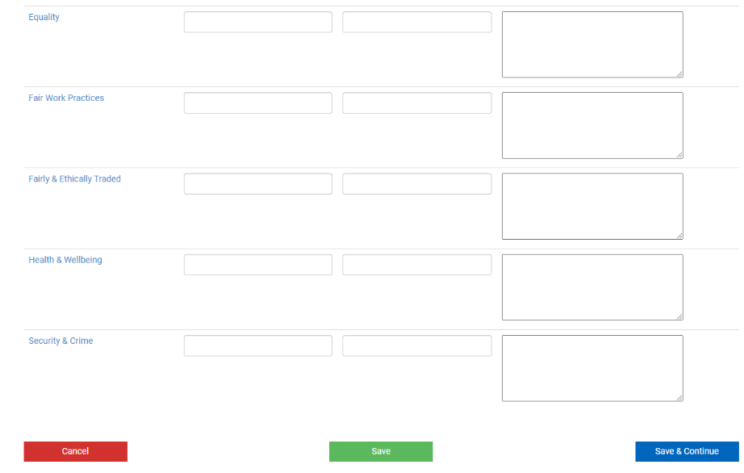
Once you have input relevant strategies click on Save (which keeps you on this page) or Save & Continue, which takes you back to the Overview.

*Example of available guidance – in this case for ‘Climate Change – Vehicles’ (this would open in a separate window):
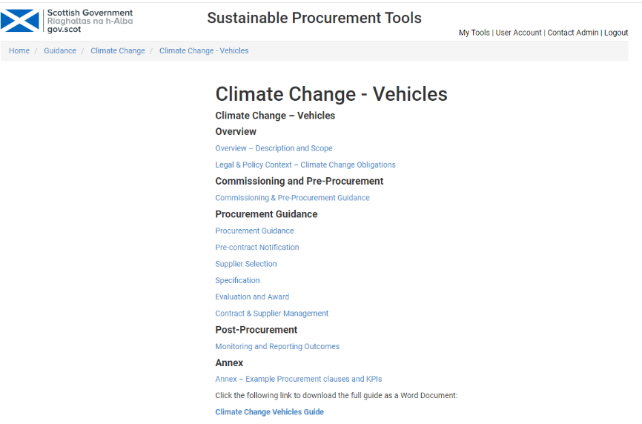
The guidance for the environmental and socio-economic issues is also available from the home page of the Tools portal under ‘Sustainable Procurement Guidance’ – you do not need to login to access this.

Adding issues
Depending on your organisational objectives you may wish to add environmental or socio-economic issue(s). Where relevant select the Type, the name of the New issue and Save.
Note:
The embedded issues in the tool cannot be removed.
If you add further issues they cannot then be removed.

Return to Contents

Complete a prioritisation assessment - input ‘categories’ & spend
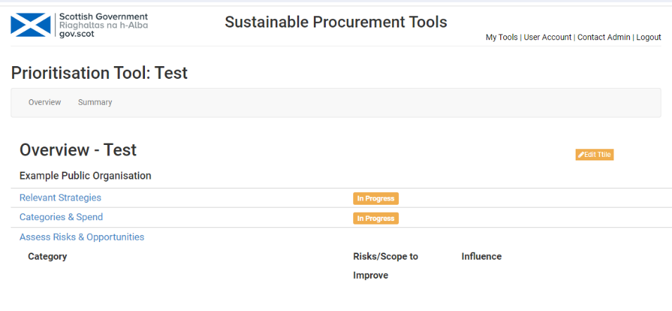
5. Click on Categories & Spend.
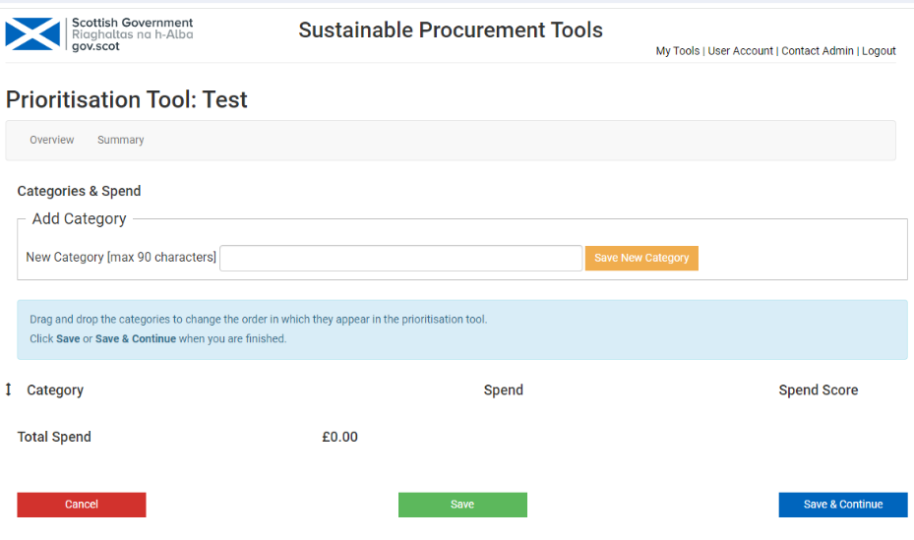
Type in the first ‘New Category’ – in practice this may be a category, sub-category, commodity, service or pipeline project. Then click ‘Save New Category’.

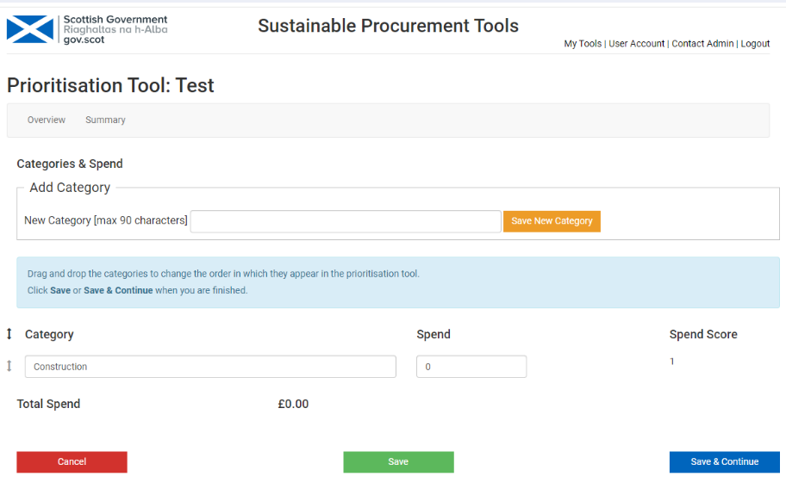
Then type in relevant Spend.
Then click Save after each new category.
Click on Save & Continue once all categories and spend have been added. This takes you back to the assessment for the first category. Each category will be allocated a spend score from 1 to 5 (with 5 representing the top 20% of expenditure).

Return to Contents

Complete a prioritisation assessment - assess risks & opportunities
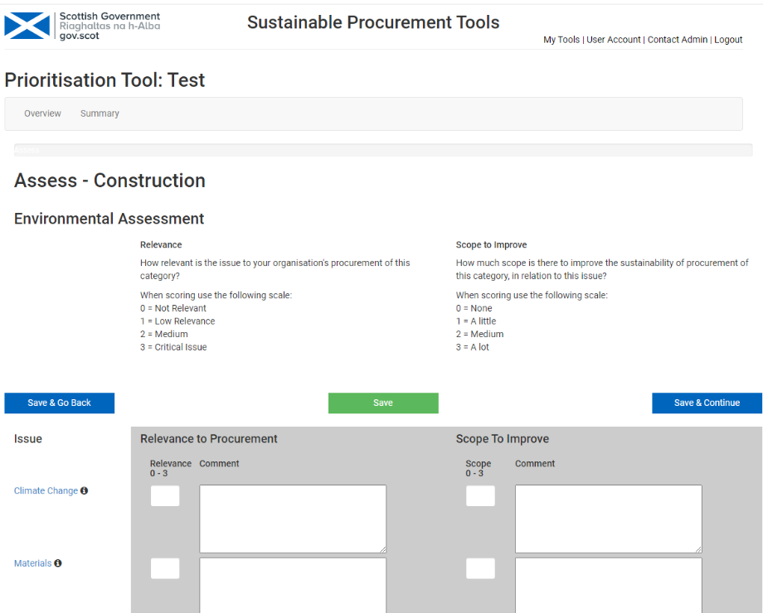
6. Relevance to procurement and Scope to improve
This is where each category in your prioritisation will be assessed for Relevance to procurement (how relevant is the issue to the category being assessed) and Scope to improve (how much more can be done to improve relevant sustainability outcomes through procurement), against the environmental and socio-economic headline risks.

In Relevance to procurement a score of zero (0) to 3 needs to be input with 3 representing a critical issue. If you feel that any of the default headline environmental and socio-economic risks are not relevant to your organisation score them as Zero (0).
It is good practice to add notes in ‘Comment’ explaining the reasoning for the scoring. This shows others who may not have been involved in the assessment how the scores have been arrived at and provides an audit trail.
You can click on each issue heading to view the relevant guidance.
Scope to Improve
This is where you determine whether you can do more, through the procurement process, to achieve intended sustainable outcomes to either mitigate environmental and socio-economic risks or capture opportunities. Scope scores will change over time, as the focus on sustainability and markets develop. Adding evidence for the scores in ‘Comment’ will help demonstrate progress.
Total scores
Risk scores are averaged and weighted so that those identified as being critical score higher.
Reputational Risk
At the bottom of this page is where you will assess the reputational risk associated with the procurement of each category, or other, in your prioritisation.
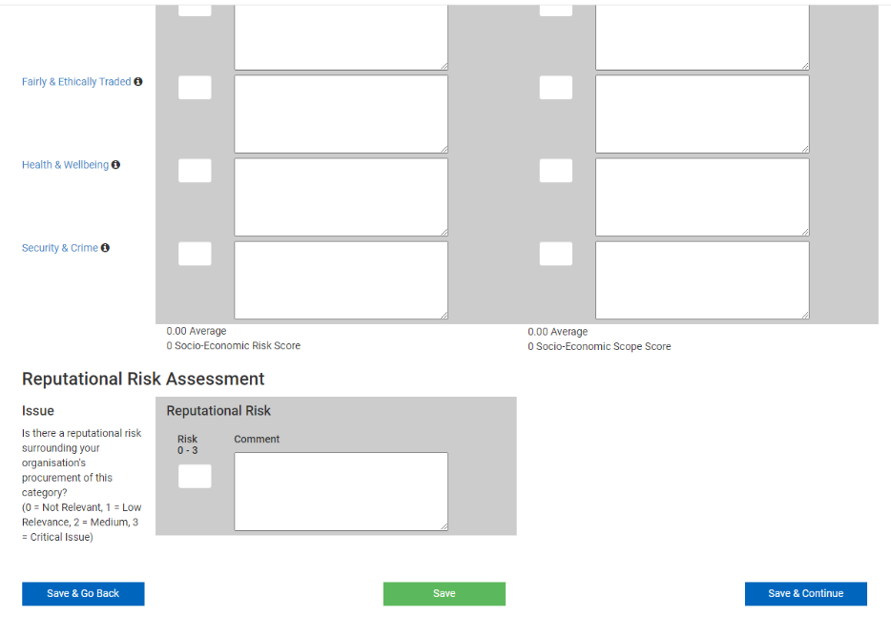
7. Score reputational risk from zero (0) to 3. Add notes explaining the scoring in ‘Comment’.
It does not necessarily follow that a ‘category’ with high environmental or socio-economic risk also has high reputational risk and vice versa. For example, textiles may have a high reputational risk given potential concerns regarding labour conditions in the supply chain, construction as a broad category may have high environmental and socio-economic risks as well as a high reputational risk, due to labour standards, health and safety and other concerns.
Make sure you consider the life cycle of the relevant product or service within the ‘category’.

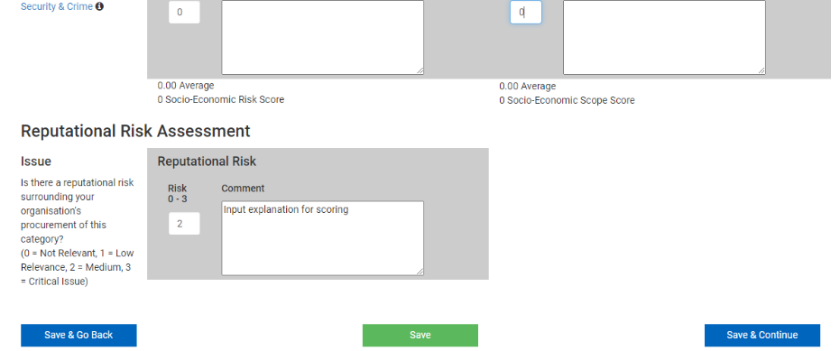
8. Once you have assessed each issue fully click on:
Save & Go Back – this saves your detail and takes you back to the previous assessment.
Save – this saves you detail and keeps you on the current page.
Save & Continue – this saves your detail and takes you to the assessment of Influence.
Return to Contents

Complete a prioritisation assessment - assess influence

Assessment of market influence
This is where each ‘category’ of your prioritisation will be assessed for the level of influence your organisation might have over the market to improve sustainability outcomes.
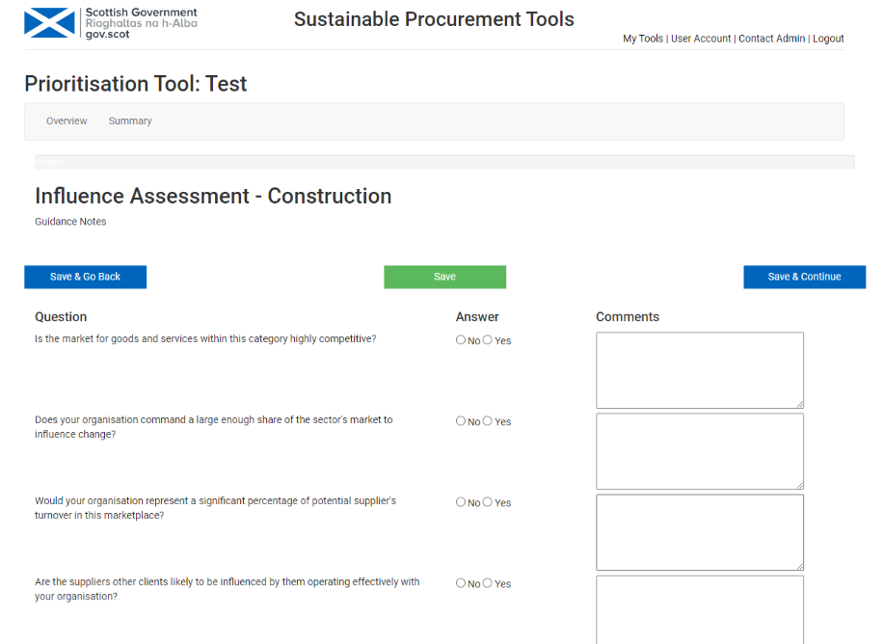
9. Answer the seven questions Yes or No. Add relevant notes in ‘Comments’. For example, the market is competitive due to the number and reach of potential suppliers.
See the following that helps with the assessment of influence:

Influence assessment considerations
Is the market for the goods and services within this category highly competitive? Determine if there are numerous players in the market all competing for business (i.e. consumer goods, IT equipment, vehicles, stationery etc.).
Does your organisation command a large enough share of the sector’s market to influence change? Holding a significant minority proportion of the market (5% or above) helps the Public sector steer the sector, not merely from a profit perspective from individual suppliers but from a competition perspective from potential suppliers.
Would your organisation represent a significant percentage of a potential supplier’s turnover in this marketplace? Reflect upon the supplier’s turnover and determine if this contract is more than about 0.5% of their turnover. If it is, this will be considered a significant purchase from a value perspective. The supplier may only have around 20 clients who singularly account for more than ½ a percent of their turnover
Are the supplier's other clients likely to be influenced by them operating effectively with your organisation? Reflect upon our brand and its weight to the supplier. By having the Public Sector as a client will the supplier gain credibility with other clients as being dependable?
Is society at large likely to be influenced by suppliers operating effectively with your organisation? Consider the image connotations associated with adherence to Public sector policy (i.e. sustainable development strategy) which implies innovation and corporate responsibility.
Will suppliers enhance their policy and practice as a result of operating to your policies? Has the Public sector implemented efficiency drives or sector strategies to improve supplier operations? Does working with the public sector educate suppliers on important sustainability questions which could be answered in supplier policy/strategy?
Are you likely to be considered an attractive proposition to potential suppliers within this category? Consider whether a partnership with a public sector client may provide your suppliers with new opportunities to make improvements to their services and products.
10. Once you have assessed each issue fully click on:
Save & Go Back – this saves your detail and takes you back to the previous assessment.
Save – this saves you detail and keeps you on the current page.
Save & Continue – this saves your detail and takes you to the next ‘category’.
Once you have assessed all ‘categories’, you will be taken to ‘Overview’

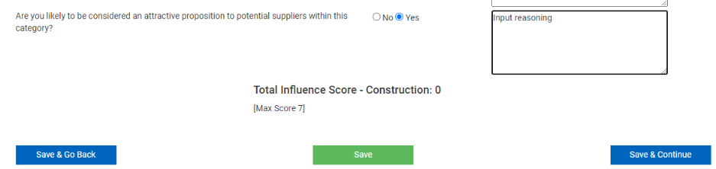

Return to Contents

Overview - results of prioritisation assessment

Status of assessment
The Overview shows the status of the assessment of ‘categories’. If anything is shown as ‘In progress’ you should click on the relevant hyperlinked heading, to complete as necessary.

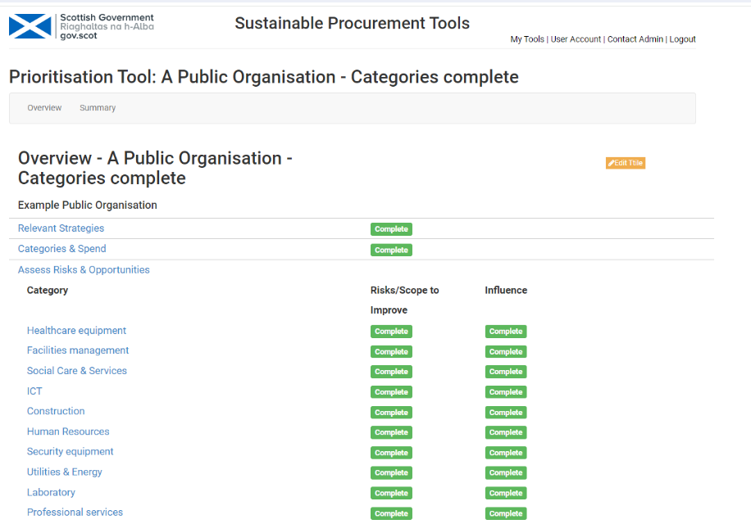

Risk vs Spend
Beneath the list of categories and their status is the first matrix.
This shows the relationship between spend and all risks (Environmental, Socio-economic and Reputational). It identifies those ‘categories’ in the top right hand quadrant which combine a high spend score with high risk & opportunity score; these are priority categories and your organisation should focus overall effort on these. It does not mean the other categories should be ignored as there may be opportunities to capture simple improvements within these, but it emphasises those categories which are strategically important. The results can be used to inform category, or equivalent, strategies.
There may be a specific category that has a much higher spend than another (e.g. construction) which can skew the results. In these circumstances the user may wish to run the prioritisation, then run it again without the high spend category to see how this impacts the results.
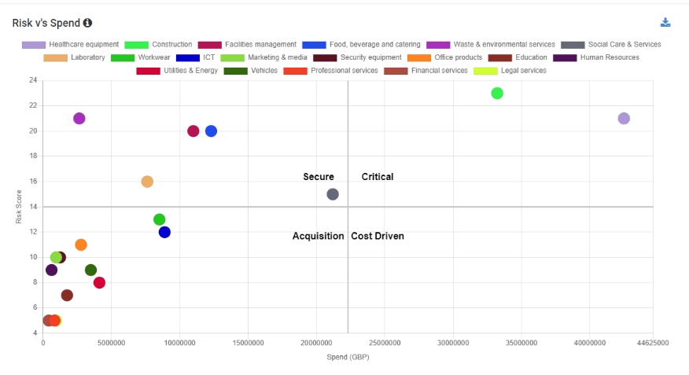
‘Categories’ are represented by a coloured circle and the key at the top.
If more than one ‘category’ appears at the same point, this will become visible when the user hovers over the circle.
There four quadrants with different headings. To view a description of the quadrants and what results mean for relevant ‘Categories’ click on the information button.
Click on ‘Close’ when you have finished viewing this.

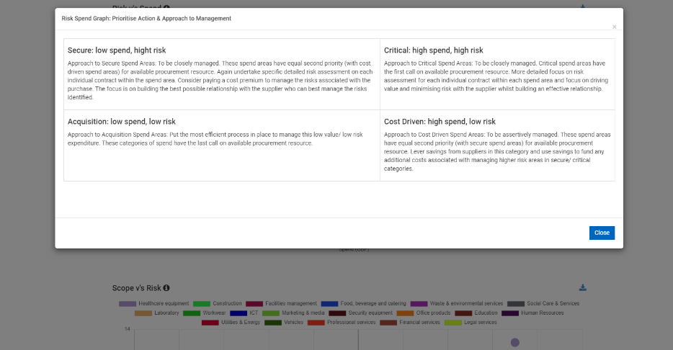
Return to Contents

Scope vs Risk matrix
This matrix displays the risks and opportunities scores relative to the scope to do more to mitigate the risks or capture the opportunities for each category.
This graph is designed to help your organisation determine how to approach buyers. It emphasises the approach that should be taken by procuring organisations to focus on what it can do to improve sustainability outcomes; for example, through relevant requirements it may place on suppliers through contract specification and contract management but also through potential collaboration, improvements in the use of products or services, consideration of new business models, etc.
As with the first matrix hover over the coloured circles to see the relevant ‘categories’ titles and information box which describes the quadrants and what these mean for the ‘categories’.
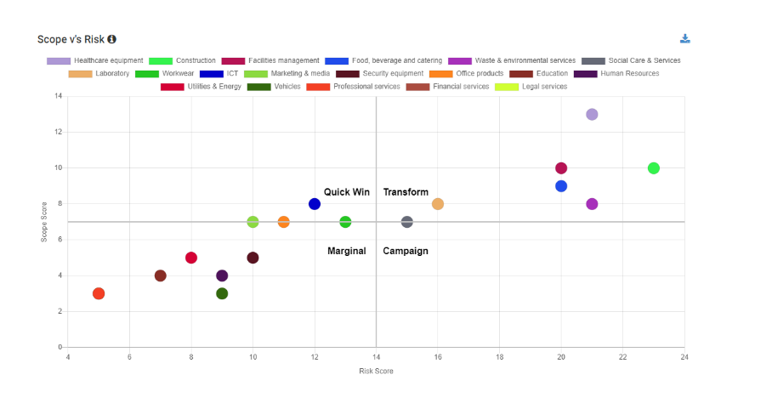
Return to Contents

Scope v’s Influence matrix
This matrix displays the scope to do more to mitigate these risks or capture the opportunities relative to the influence your organisation potentially has over the market.
This graph highlights the approach that should be taken by the procuring organisation to market engagement; it highlights for example those product groups where you have a high degree of influence over the market and there is significant scope to do more to improve sustainability outcomes. Engagement with potential suppliers of these product groups offers opportunities to discuss the potential for innovative solutions, such as new business models, 'closed loop' solutions as well as current understanding and application of the procuring organisation's sustainable procurement objectives.
As with the first matrix hover over the coloured circles to see the relevant ‘categories’ titles and information box which describes the quadrants and what these mean for the ‘categories’.

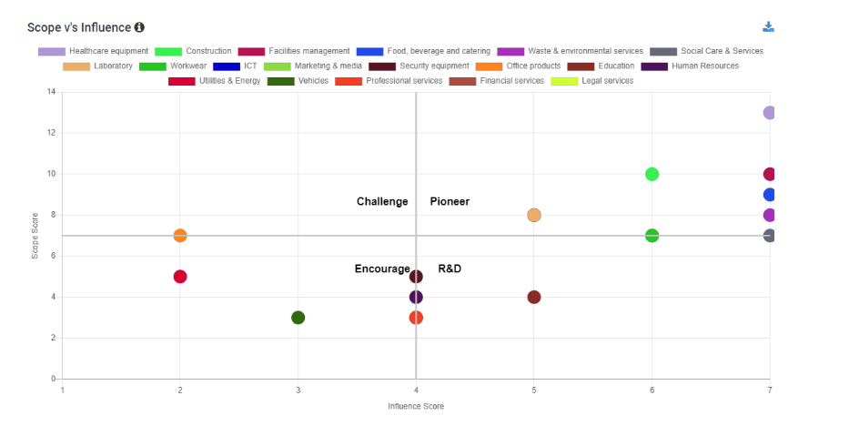
Return to Contents

Overall graph
This chart summarises the combined risk and opportunity score, scope score and influence score for each ‘category’. It is designed to help your organisation determine which categories, or other, to prioritise initially, and focus most time and resources on first.
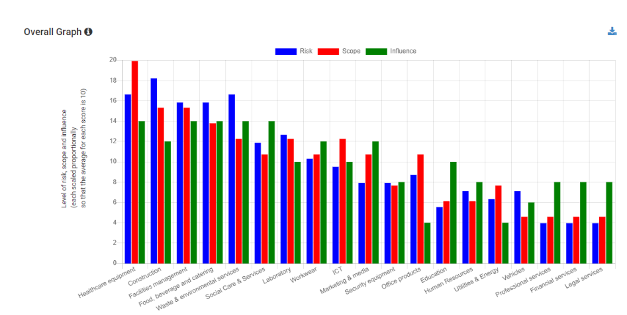
Each ‘category’ has a coloured bar representing its Risk, Scope and Influence scores.
Categories’ with the highest combined scores are to the left of the chart, and represent the highest ‘overall priorities’.
All the matrices and graph can be downloaded and saved locally, or copied into the procurement strategy, etc. as required, by clicking on the download icon at the top right of them.

Return to Contents

Results of prioritisation assessment – summary
At the top of the Overview you can click on ‘Summary’.
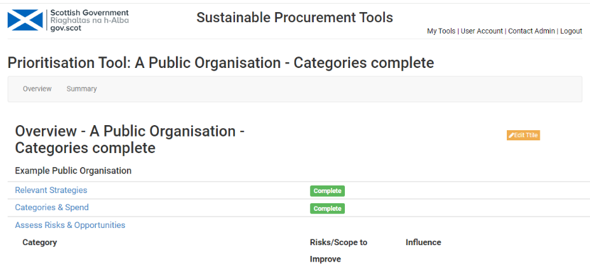
This provides the user an overview of their completed prioritisation assessment.
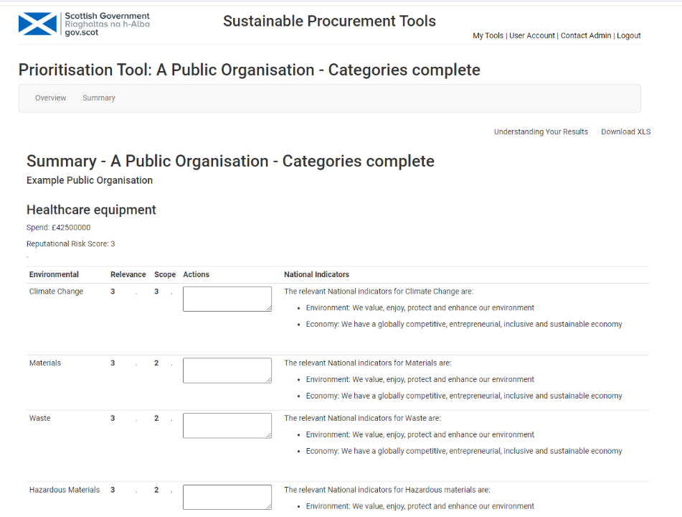
The user can add the actions proposed for each category in relation to the headline risks. Actions are automatically saved.
The summary can be downloaded and saved locally, shared with colleagues, or incorporated into the procurement strategy, etc. as required.
Return to Contents

Prioritisation assessments – duplicating
You can duplicate an existing prioritisation assessment if you wish.
For example, if prioritisation is refreshed annually, you can copy the previous assessment, as a starting point. This will need adjusting to suit the current situation.
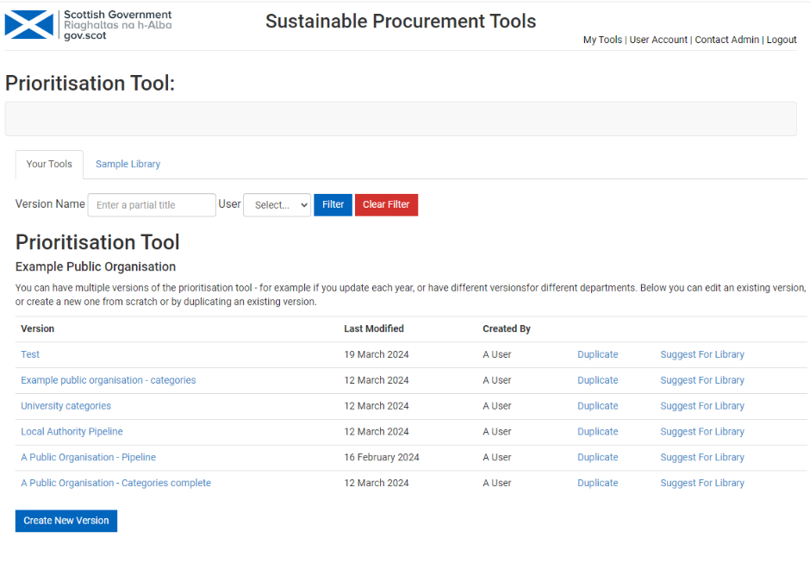
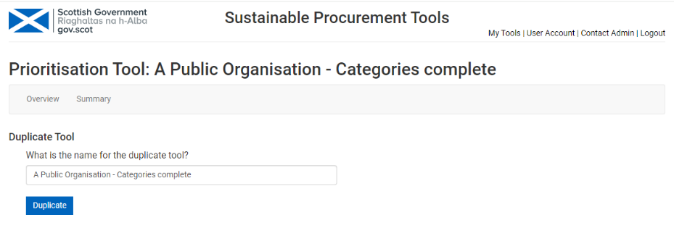
Overwrite the name of the duplicate tool. Then click Duplicate.
The copied version will then appear on the Prioritisation Tool page.

Return to Contents

Any feedback or questions on the tools can be sent to scottishprocurement@gov.scot

