User Guide - Life Cycle Impact Mapping
Contents
1. Introduction 1
2. Examples of Life Cycle impact Mapping 3
2.1 Impacts of obtaining raw materials / resource needed for service 3
2.2 Impacts of manufacturing and logistics / set up of service 3
2.3 Impacts during use of product/ delivery of service 3
2.4 Impacts at end of life / disposal 3
2.5 Impacts of obtaining raw materials 3
2.6 Impacts of manufacturing and logistics 3
2.7 Impacts during use of product/service 4
2.8 Impacts at end of life / disposal 4
2.9 Impacts of obtaining raw materials 4
2.10 Impacts of manufacturing and logistics 4
2.11 Impacts during use of product/service 4
2.12 Impacts at end of life / disposal 4
3. Who needs to be involved in completing this? 5
4. Where do I Input the Data for Life Cycle Impact Mapping? 6
5. To input life cycle impacts 6

Introduction
This guidance complements short videos on the Life Cycle Impact Mapping tool:
- Introduction to the Life Cycle Impact Mapping Tool.
- Using the Life Cycle Impact Mapping Tool.
These videos use an example of a Cleaning Service contract.
Life cycle impact mapping is used to identify and assess the environmental and socio-economic impacts of products, services or works, during life cycle stages:
- from the extraction and sourcing of raw materials, such as mining, or the resources needed to establish a service, such as labour.
- to the manufacture and transportation of products, or the setup of a service, which may use products.
- to the use of products or works or the delivery of a service.
- to the end-of-life management, such as re-use, recycling, remanufacture and final disposal of products/ materials, or the closure of a service.
Using life cycle impact mapping:

- is designed to be an ‘easy way in’ to assessment of risks and opportunities in the Sustainability Test.

- can help get budget-holders, specifiers, end users on board.

- assumes limited time and expertise available at first.

- aimed at prioritising efforts.

Note: not all risks and opportunities identified here can be addressed through procurement stages!

When considering the major environmental and socio-economic risks and opportunities which are relevant to a particular procurement, it is important to consider where in the life cycle they apply

For example, this may identify that key risks and opportunities relate to the manufacture of a product, in which case (if procurement is from manufacturers) you may focus on the production process, and how environmental impacts may be reduced. Alternatively, life cycle impact mapping may identify key risks and opportunities relating to the delivery of a service.

It should be used at the earliest possible opportunity, in the development of a commodity or procurement strategy, for a specific framework or contract.

Examples of Life Cycle impact Mapping

Life Cycle thinking:
Employing a Life Cycle Approach helps clarify relevant risks and opportunities and actions to manage sustainability at relevant stages of the procurement process.
Figure 1: Life Cycle Impact Map - life cycle stages and actions at stages of procurement process

Impacts of obtaining raw materials / resource needed for service  Focus on specification, suppliers own procurement | Impacts of manufacturing and logistics / set up of service  Focus on supplier selection stage
Impacts during use of product/ delivery of service  Focus on specification and end user awareness | Impacts at end of life / disposal  Focus on supplier responsibility and end user awareness

Biomass energy
Impacts of obtaining raw materials  Sourcing overseas if demand outstrips supply – impact on carbon emissions.  Wood should be sourced not just from legal but also sustainable forests/woodlands – forest management critical.  Potential impact on biodiversity of forests / woodlands if focus is only on economic viability.  Support development of an immature supply chain through aggregated demand.  Opportunities for community woodland schemes to be integral to supply chain | Impacts of manufacturing and logistics  Carbon emissions from transportation, particularly if local supply chains are inadequate.  Production of chips / pellet – is renewable energy used.  Sourcing overseas if demand outstrips supply – impact on carbon emissions.  Competition for raw materials e.g. chipboard manufacturers.  Waste products from pellet manufacturing process.
Impacts during use of product/service  Emissions particularly in ‘Air Quality Management Areas’  Shortage of qualified engineers / installers ; through aggregated demand an opportunity to influence recruitment | Impacts at end of life / disposal  Disposal of ash – use as a fertiliser  Disposal of boilers

Hard Facilities Management
Impacts of obtaining raw materials  Timber and stone: Sustainable sourcing.  Recycled content of materials, products  People: training  People: transfer of existing staff | Impacts of manufacturing and logistics  Training of workforce  Vehicle movements and emissions  Packaging  Safe storage and transport
Impacts during use of product/service  Energy: use of equipment, energy management  Waste: compliance and hierarchy  Water Reduction  Biodiversity impacts, protection and enhancement  Heritage protection  Materials: sustainable (e.g. timber, stone etc.)  Recycled content of materials and products  Community benefits: training and education  Fair work  Equality  Emissions to air, land, water  Noise emission and nuisance  Health and safety  Safe storage of chemicals and equipment  Training of workforce  SME’s as sub-contractor | Impacts at end of life / disposal  WEEE compliance  Waste management (in accordance with hierarchy and legal compliance)  Re-use, repair, remanufacture of equipment, tools and materials  3rd sector, SME involvement  Training of staff  People: transfer of existing staff

Return to Contents

Who needs to be involved in completing this?

As well as an ‘easy way in’ to assessment of risks and opportunities in the Sustainability Test, it can also be used in isolation for analysing risks and opportunities, opportunities for innovation, to highlight gaps in knowledge and also planning for alterative scenarios.
This can help key stakeholders involved, such as senior officers, budget-holders, specifiers and end users, in collaboration with procurement and subject matter experts.
If carried out by a group of stakeholders drawing on the expertise and experience of the group, users can then make informed decisions about the extent to which they can address these risks and opportunities and, crucially, the stage of the procurement process at which it is best to do so, and who needs to be involved.

Where do I Input the Data for Life Cycle Impact Mapping?

Life cycle impact mapping sits between the strategic planning Prioritisation Tool and the Sustainability Test. Specifically, it is located within the Sustainability Test, to the left hand-side of the tool.

Return to Contents
9

To input life cycle impacts

Having logged in (if unclear how to Register and login see the ‘Register and Login’ guidance under user guides and videos:

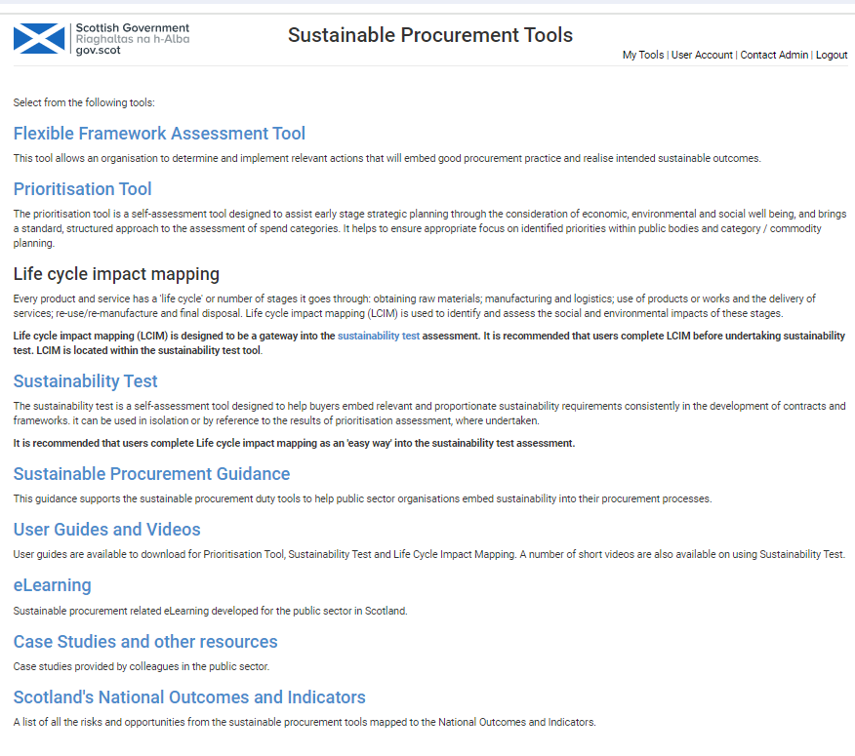
Click on Sustainability Test

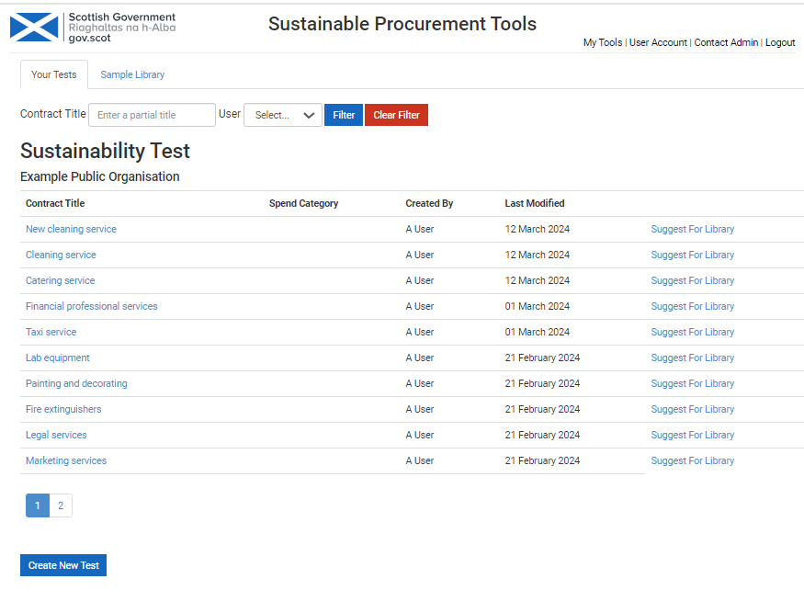
If you are creating a new Life Cycle Impact Map Click on Create New Test – otherwise click on the relevant Test from the list above.
For information: All Sustainability Tests created are visible to other users within your organisation.

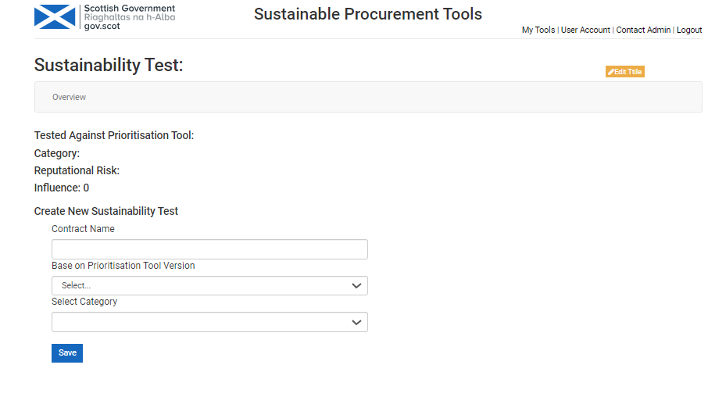
If you are creating a new Life Cycle Impact Map input the title of the Contract or Framework here, then click Save.
You will then see this appear at the top of the list of Sustainability Tests – click on this.

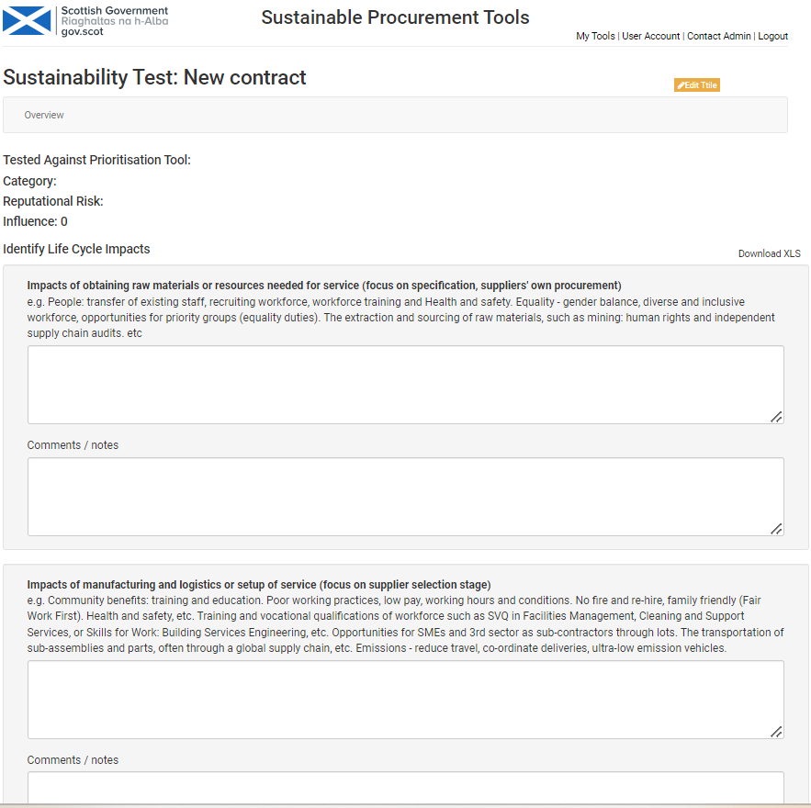
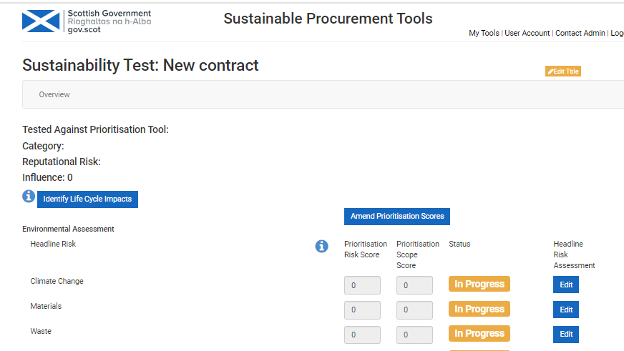
Then input details of impacts at each of the 4 stages.
You can make Comments/ notes below to, for example, provide additional supporting information if required.
Then click on Identify Life Cycle Impacts.
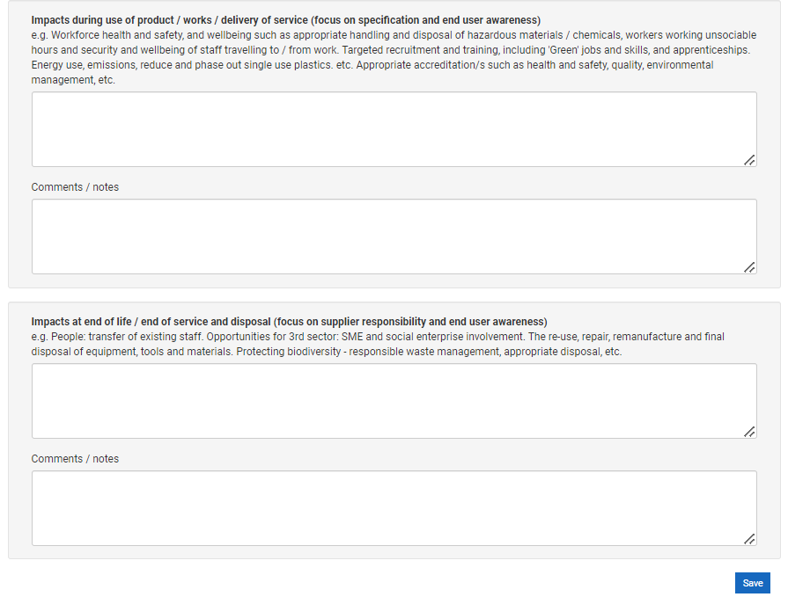

When you have finished click Save.

Any feedback can be sent to scottishprocurement@gov.scot

Return to Contents

